BOOKING ACTIVITIES ONLINE FOR CHILDREN APP

ISCG7427 Agile and Lean Software Deliver Sprint 0 & Sprint 1

Group Name: Drinking Flask

Group Member: Alexandre Angrignon, Liuzhi Huang

# Environment Links

**YouTrack Server Link:** <https://alexam13.myjetbrains.com/youtrack/>

**GitHub Link:** <https://github.com/alexangria1992/ISCG_7427_Assignment>

**Host server Link:** <https://activity-staging-app.herokuapp.com/>

**Gitlab Link(Stand up Meeting):** <https://gitlab.com/drinkingflask/drinkingflask>

# Vision Statement

At this moment in time, parents of young children in school reserve their children’s educational and physical activities through various websites or through email with their respective coaches and instructors. The parent proceeds to paste each of the children’s activities by hand on a physical schedule on their house wall. This system is tedious and could be improved significantly. It is also causing increased stress as the parent’s have to allocate extra time in their morning routine to allow for this scheduling procedure on top of everything else they need to do in order to get ready. It is also mistake-prone as people are relied on as the system rather than a computer.

For parents who waste time transcribing and scheduling their child’s extra-curricular commitments, the Child Commitment Schedule Application is a web application that gives permission so that parents can submit their child’s extra-curricular commitments online, and also gives permission for parents to check their children’s extra-curricular commitments providing the parents with the exact drop off information so the parents can leave on time, with less effort and error unlike the manual error-prone effort performed previously.

**Milestone 3**

# Updated Product Backlog

**Our youtrack Link:**

<https://alexam13.myjetbrains.com/youtrack/dashboard?id=60fa6ced-f542-4012-aa20-d69d9172445a>

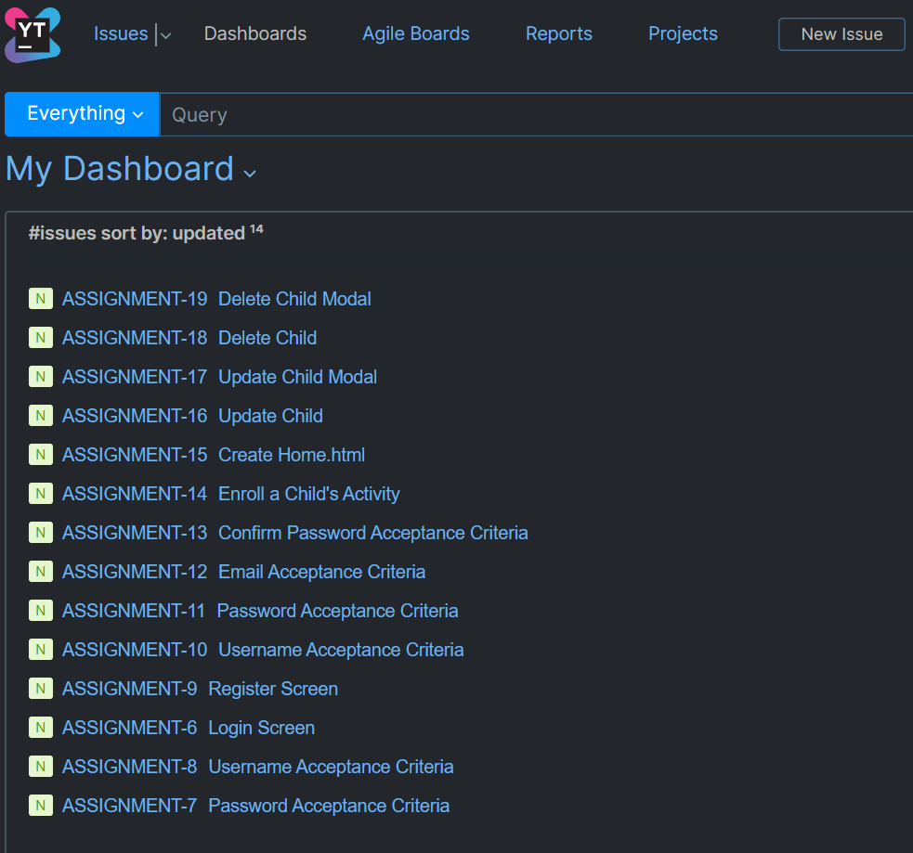

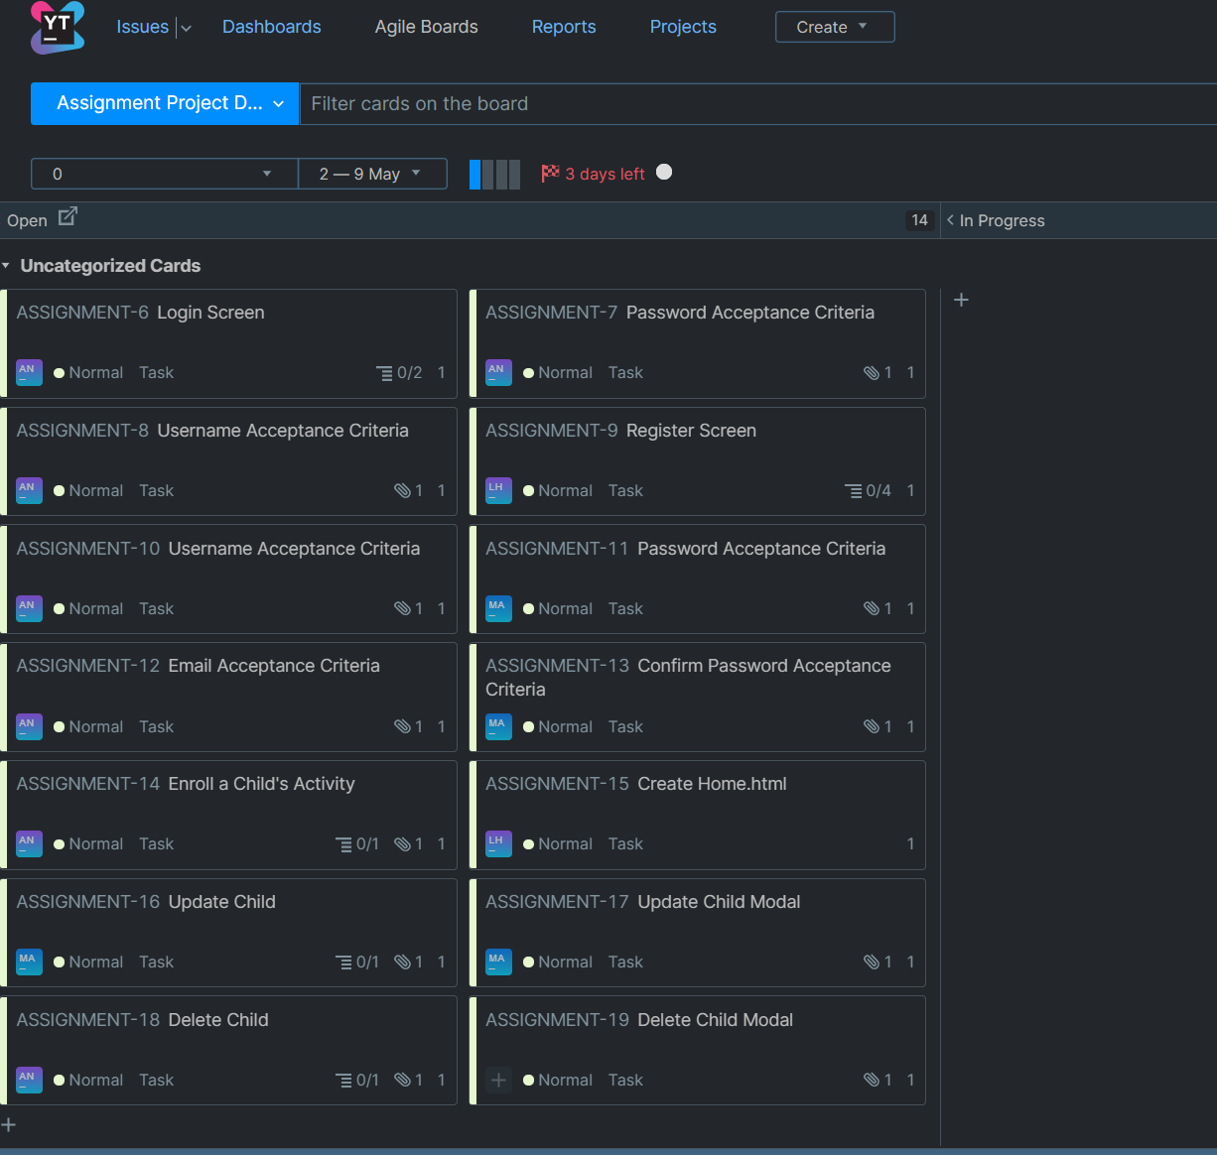

## Five priority user stories and tasks

1. **PRIORITY: HIGH *- As a*** *Parent* ***I want to*** Login my children(s) activities onlineaccount ***so that*** I can access and manage my account.

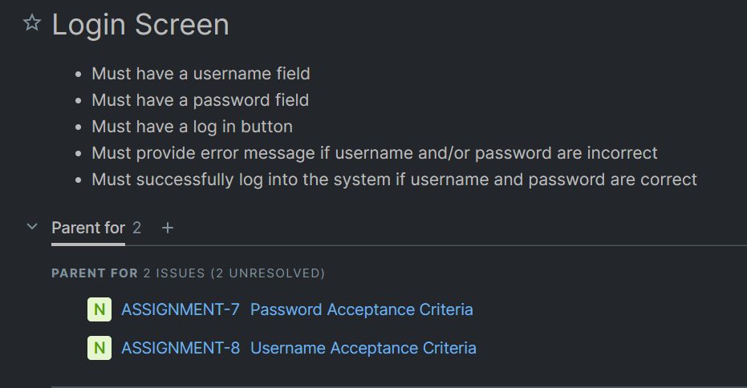

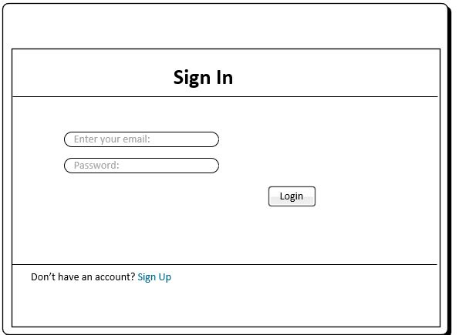

1. **PRIORITY: HIGH *- As a*** *Parent* ***I want to*** register a children(s) activities onlineaccount ***so that*** I can enroll my children(s) activities online.

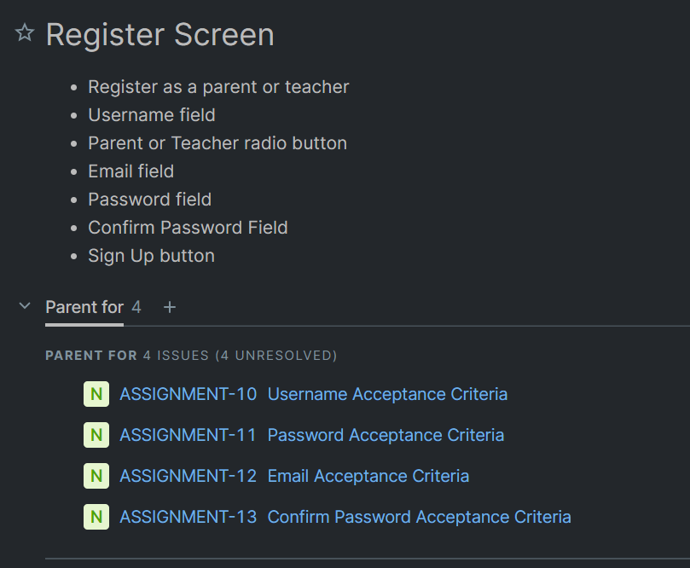

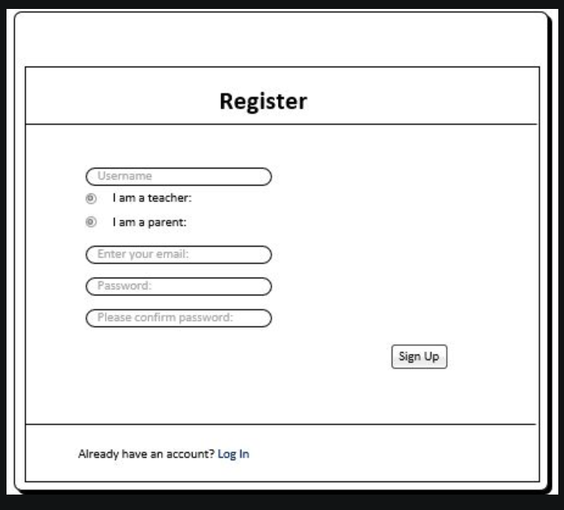

1. **PRIORITY: HIGH *- As a*** *Parent* ***I want to*** enroll my children(s) activities online ***so that*** I don’t have to manually input into the paper-based calendar, reducing error and effort in the process***.***

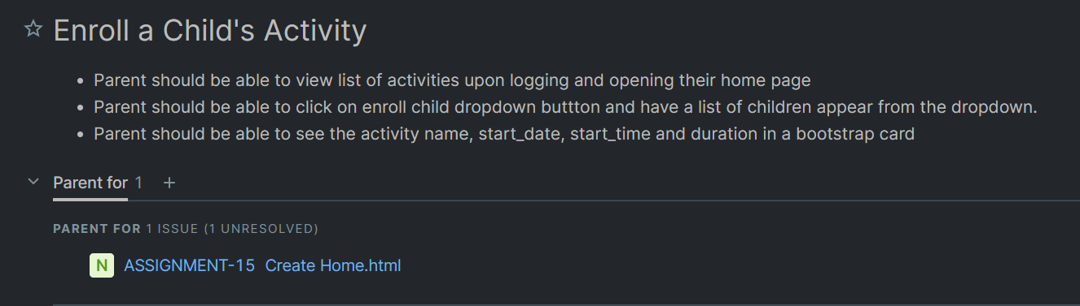

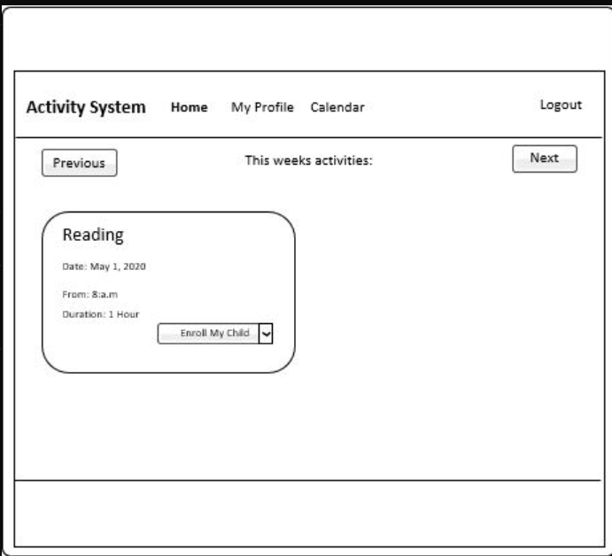

1. **PRIORITY: HIGH *- As a*** *Parent* ***I want to*** remove my children(s) from activities online ***so that*** I don’t have to manually delete from the paper-based calendar, reducing error and effort in the process***.***

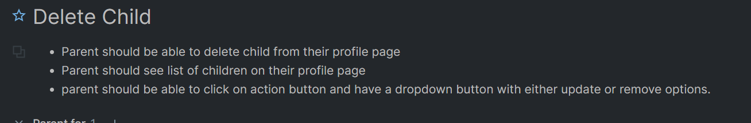

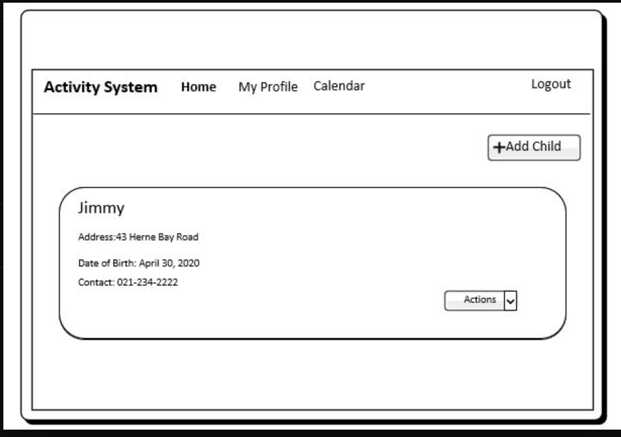

1. **PRIORITY: HIGH *- As a*** *Parent* ***I want to*** update my children(s) time slot of an activity online ***so that*** I don’t have to manually change the paper-based calendar, reducing error and effort in the process***.***

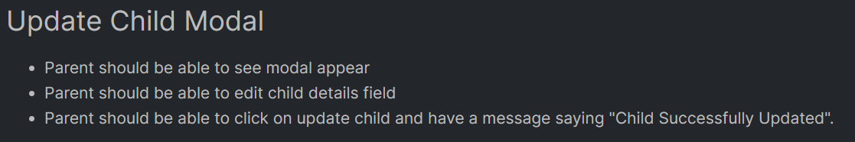

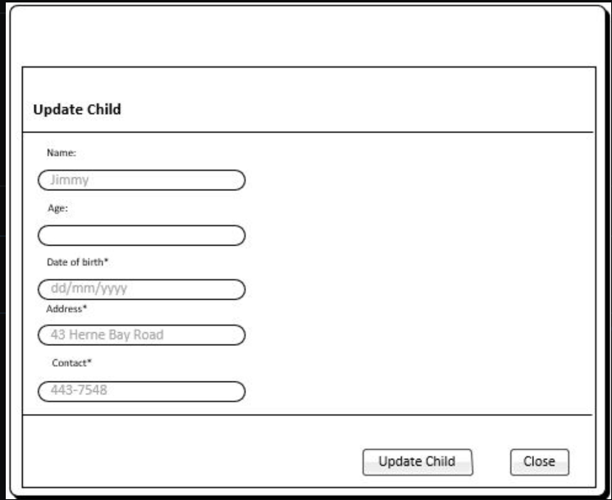

## INVEST Acceptance Criteria

**Create a User Login Screen**

**Create a Register Screen**

|  |  |
| --- | --- |
|  | Yes – this story can be developed independently of other user stories |
| N – Negotiable | Login screen should be negotiated within team members as to what it should look like, and what restrictions should be put in place in terms of account privacy. |
| V - Valuable | Having the ability to log into a system means the teacher or parent can perform scheduling, updating and deleting tasks from an application rather than have to do it manually |
| E - Estimable | This story would require about 2 to 3 hours to complete. |
| S – Small or Sized Appropriately | The story is small enough to be dealt with by a team member without too much difficulty |
| T - Testable | The story will be tested by checking to see if the user is logged in as their account name by showing a successful message. Or if it is not the right username or password, the system should send an error message. |

|  |  |
| --- | --- |
| I - Independant | Yes – this story can be developed independently of other user stories |
| N – Negotiable | Register screen should be negotiated within team members as to what it should look like, and what restrictions should be put in place in terms of account privacy. |
| V - Valuable | Having the ability to Register into a system means the teacher or parent can have access into the system by logging in as either a parent or a teacher. |
| E - Estimable | This story would require about 2 to 3 hours to complete. |
| S – Small or Sized Appropriately | The story is small enough to be dealt with by a team member without too much difficulty |
| T - Testable | The story will be tested by checking to see if the user is logged in as their account name by showing a successful message. Or if it is not the right username or password, the system should send an error message. |

**Enroll a Childs Activity**

|  |  |
| --- | --- |
| I-Independent | Yes – this story can be developed independently of other user stories |
| N – Negotiable | Enroll functionality should be negotiated within team members as to what it should do, and what happens when a parent clicks on enroll child activity. |
| V - Valuable | Having the ability to enroll a child’s activity means the parent can perform scheduling, updating and deleting tasks from an application rather than have to do it manually |
| E - Estimable | This story would require about 3 to 4 hours to complete. |
| S – Small or Sized Appropriately | The story will be medium sized. |
| T - Testable | The story will be tested by checking to see if the parent is able to enroll a child’s activity successfully. It should be seen in the ‘My Profile’ page and also shown in the back end by looking at the admin page in Django. |

**Update a Child’s Activity**

|  |  |
| --- | --- |
| I-Independent | Yes – this story can be developed independently of other user stories |
| N – Negotiable | Enroll functionality should be negotiated within team members as to what it should do, and what happens when a parent clicks on enroll child activity. |
| V - Valuable | Having the ability to enroll a child’s activity means the parent can perform scheduling, updating and deleting tasks from an application rather than have to do it manually |
| E - Estimable | This story would require about 3 to 4 hours to complete. |
| S – Small or Sized Appropriately |  |
| T - Testable | The story will be tested by checking to see if the parent is able to enroll a child’s activity successfully. It should be seen in the ‘My Profile’ page and also shown in the back end by looking at the admin page in Django. |

|  |  |
| --- | --- |
| I-Independent | Yes – this story can be developed independently of other user stories |
| N – Negotiable | Update functionality should be negotiated within team members as to what it should do, and what happens when a parent clicks on Update Child Details. |
| V - Valuable | Having the ability to Update a child’s details means the parent can perform scheduling, updating and deleting tasks from an application rather than have to do it manually |
| E - Estimable | This story would require about 3 to 4 hours to complete. |
| S – Small or Sized Appropriately | The story will be medium sized. It should be similar to add child activity. There might be some impediments encountered but they should be solved easily. |
| T - Testable | The story will be tested by checking to see if the parent is able to update a child successfully. It should be seen in the ‘My Profile’ page and also shown in the back end by looking at the admin page in Django when updated successfully. |

**Delete a Child’s Activity**

|  |  |
| --- | --- |
| I-Independent | Yes – this story can be developed independently of other user stories |
| N – Negotiable | Delete functionality should be negotiated within team members as to what it should do, and what happens when a parent clicks on Delete Child. |
| V - Valuable | Having the ability to Delete a child means the parent can perform scheduling, updating and deleting tasks from an application rather than have to do it manually |
| E - Estimable | This story would require about 3 to 4 hours to complete. |
| S – Small or Sized Appropriately | The story will be medium sized. One or two other group members should try and fix a problem if there is one. |
| T - Testable | The story will be tested by checking to see if the parent is able to delete a child successfully. It should be seen in the ‘My Profile’ page and also shown to be deleted in the back end by looking at the admin page in Django. |

## Poker and Estimates

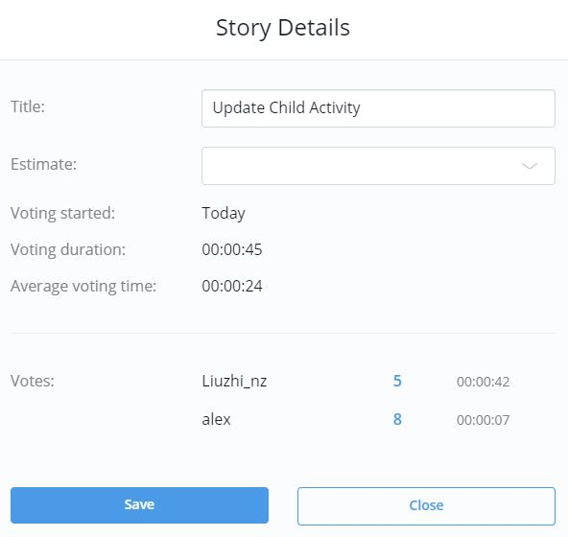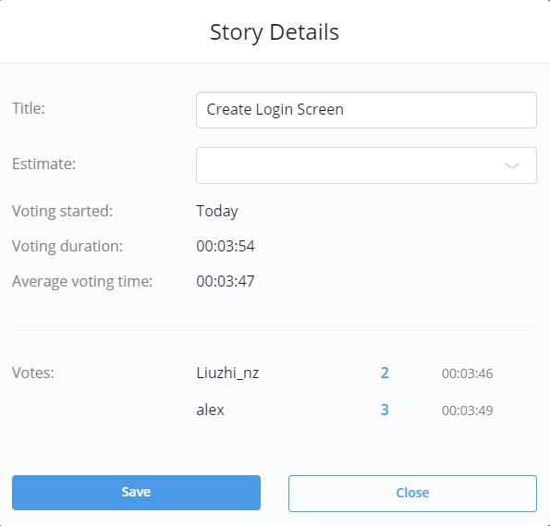 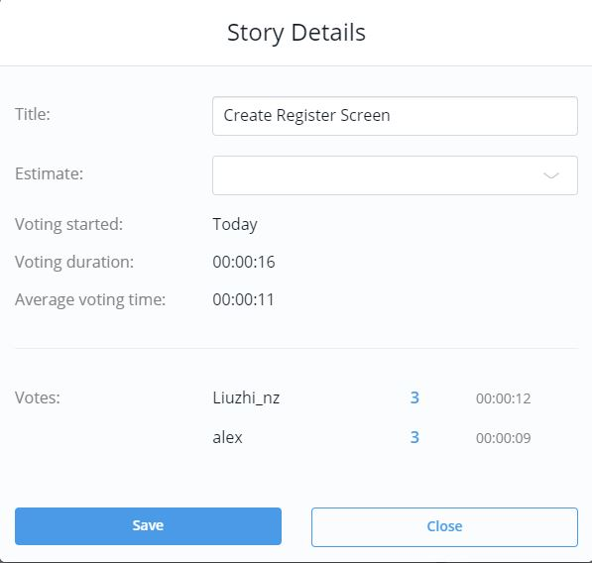 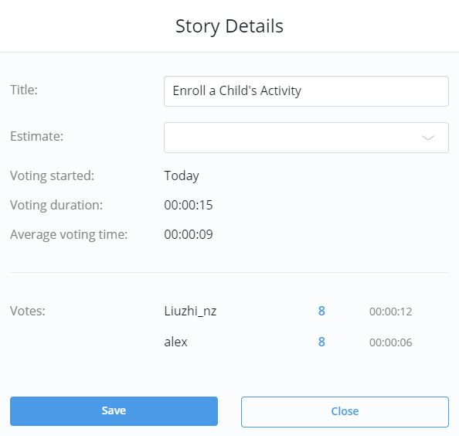

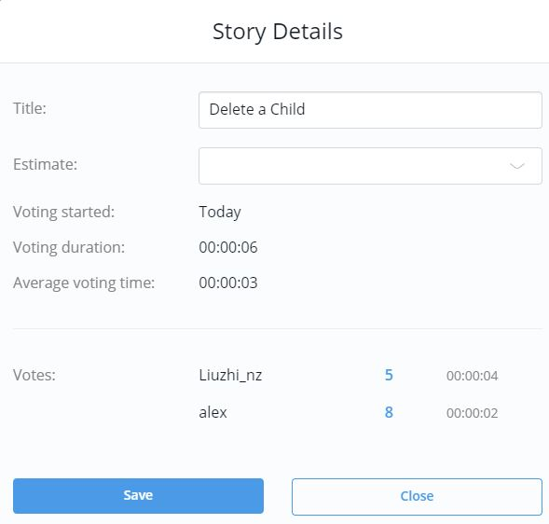



## Sprint

**Sprint 1**

1. **PRIORITY: HIGH *- As a*** *Parent* ***I want to*** Login my children(s) activities onlineaccount ***so that*** I can access and manage my account.
2. **PRIORITY: HIGH *- As a*** *Parent* ***I want to*** register a children(s) activities onlineaccount ***so that*** I can enroll my children(s) activities online.
3. **PRIORITY: HIGH *- As a*** *Parent* ***I want to*** enroll my children(s) activities online ***so that*** I don’t have to manually input into the paper-based calendar, reducing error and effort in the process***.***
4. **PRIORITY: HIGH *- As a*** *Parent* ***I want to*** remove my children(s) enrolled activities online ***so that*** I don’t have to manually delete from the paper-based calendar, reducing error and effort in the process***.***
5. **PRIORITY: HIGH *- As a*** *Parent* ***I want to*** update my children(s) time slot of an activity online ***so that*** I don’t have to manually change the paper-based calendar, reducing error and effort in the process***.***

**Sprint 2**

1. **PRIORITY: HIGH *- As a*** *Teacher* ***I want to*** add activities to the calendar ***so that*** I don’t have to manually input into the paper-based calendar, reducing error and effort in the process***.***
2. **PRIORITY: HIGH *- As a*** *Teacher* ***I want to*** delete/remove activities from calendar ***so that*** I don’t have to manually delete from the paper-based calendar, reducing error and effort in the process***.***
3. **PRIORITY: HIGH *- As a*** *Teacher* ***I want to*** update activities from calendar ***so that*** I don’t have to manually change the paper-based calendar, reducing error and effort in the process***.***
4. **PRIORITY: HIGH** - ***As a*** *Teacher* ***I want to*** remove children enrolled in my activity ***so that*** children who no longer are coming, and children I do not want at the session, are removed from the register.
5. **PRIORITY: HIGH *- As a*** *Teacher* ***I want to*** see previous and next week activities so that I can plan my schedule around this.

**Sprint 3**

1. **PRIORITY: MEDIUM** - ***As a*** *Parent* ***I want to*** view my children(s) lists of enrolled activities online ***so that*** I can view how many activities and what activities they are enrolled in.
2. **PRIORITY: MEDIUM** **- *As a*** *Parent* ***I want to*** view thedriving time approximation ***so that*** I can plan my journey and be less prone to being late to the activity***.***
3. **PRIORITY: MEDIUM** - ***As a*** *Teacher* ***I want to*** view a list of children enrolled in my activity ***so that*** I can view what children should be at my activity when I am leading the session.

**Sprint 4**

1. **PRIORITY: LOW** - ***As a*** *Parent* ***I want to*** view the time slots of a specific activity ***so that*** I can decide which time slot for a specific activity would be best around my schedule.
2. **PRIORITY: LOW** - ***As a*** *Teacher* ***I want to*** view the parents of the children in the activity ***so that*** I can contact the parent if needed.
3. **PRIORITY: LOW** - ***As a*** *Teacher* ***I want to*** have the option of being able to be a supervisor for an activity ***so that*** I can choose which activities I wish to supervise.

## Sprint Goals

**Sprint 1:** This sprint goal is complete the main frame and implement the high priority functions for parent in our web application, like register, add and delete children activities etc.

**Sprint 2:** Second Sprint goal is complete high priority for teacher’s functions in our web application to let teachers can manage the activities.

**Sprint 3:** Third Sprint goal is do the medium priority tasks main functions are view the list of activities and children for both parent and teachers to easily choose activities and manage the children

**Sprint 4:** Fourth Sprint is low priority functions the goal is let parents can easily decide which activities is suitable for their children，the driving time in which to get to the activities and also for teachers they can get more information to easily manage the children, like see previous and next week and become supervisors.

**Milestone 4**

**Updated github link:** <https://github.com/alexangria1992/ISCG_7427_Assignment>

**Updated heliohost link**: https://booking.heliohost.org/assignment1/

**Test Screenshots of Github commits for Sprint 0**

**Username Acceptance Criteria**

**Login HTML**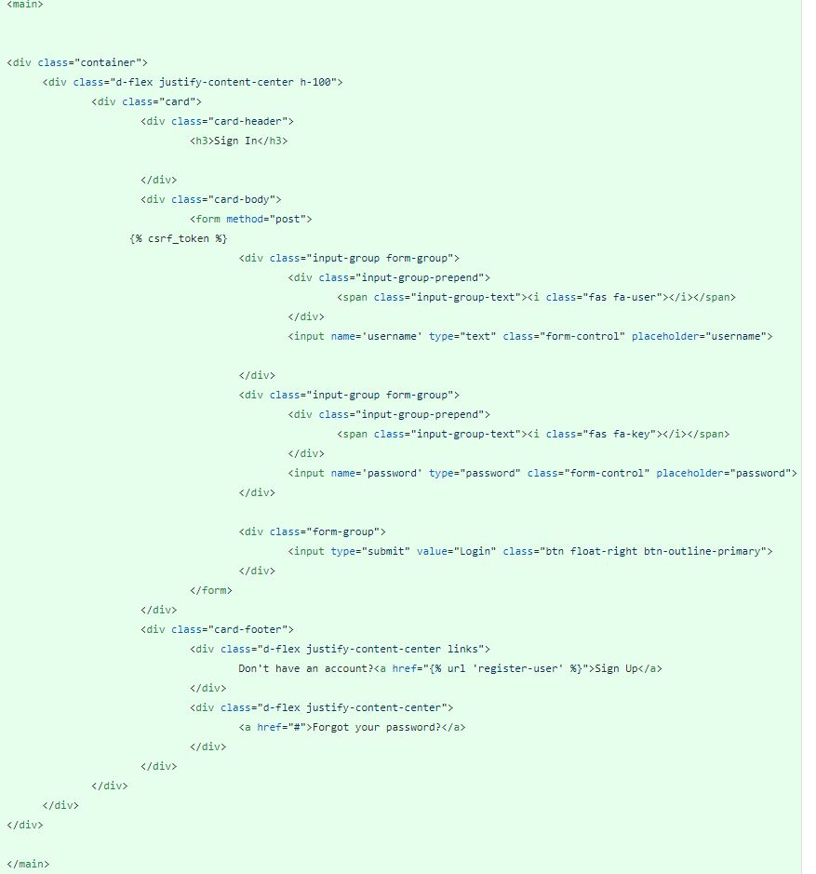

**Login CSS**

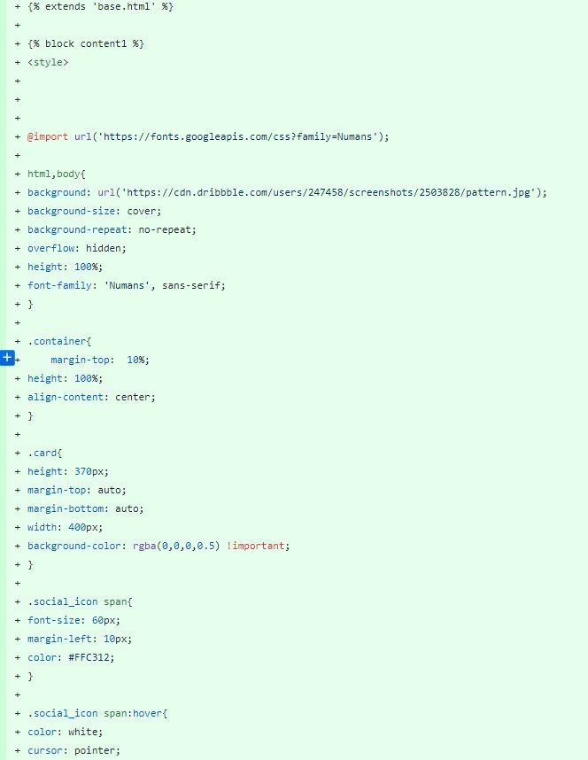

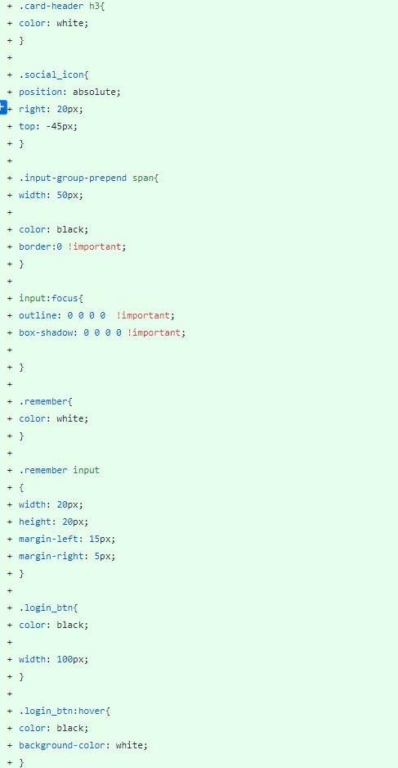

**Base HTML for importing Bootstrap, Font Awesome and Jquery**

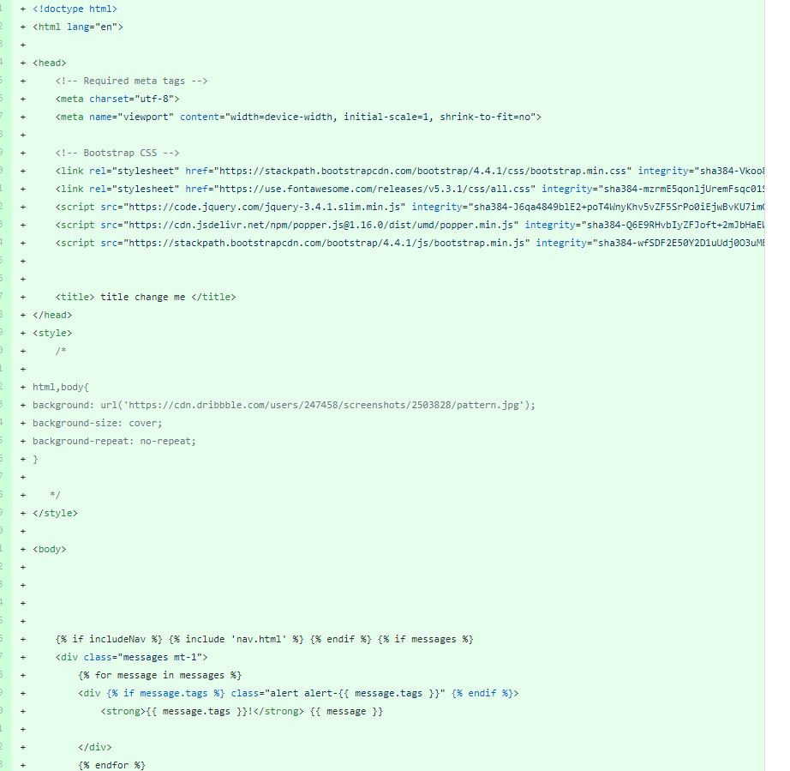

**Login Application Interface**

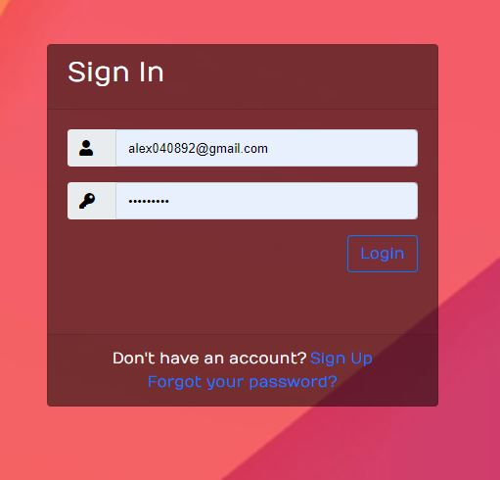

**Login Backend**

**Views.py**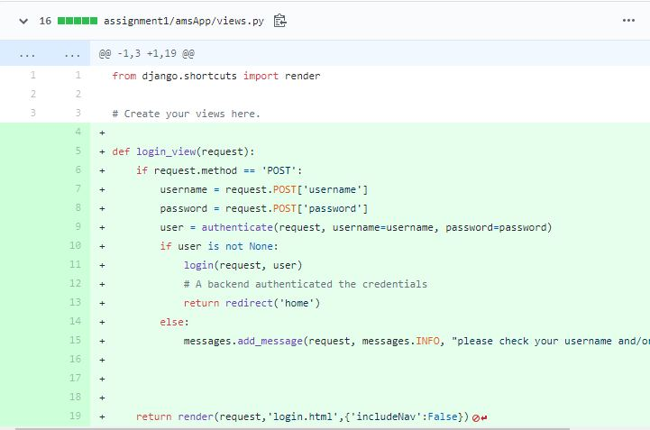

**Urls.py**

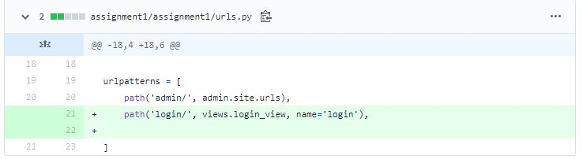

**Validation Message**

**Register Screen Acceptance Criteria**

**Register HTML**

**­**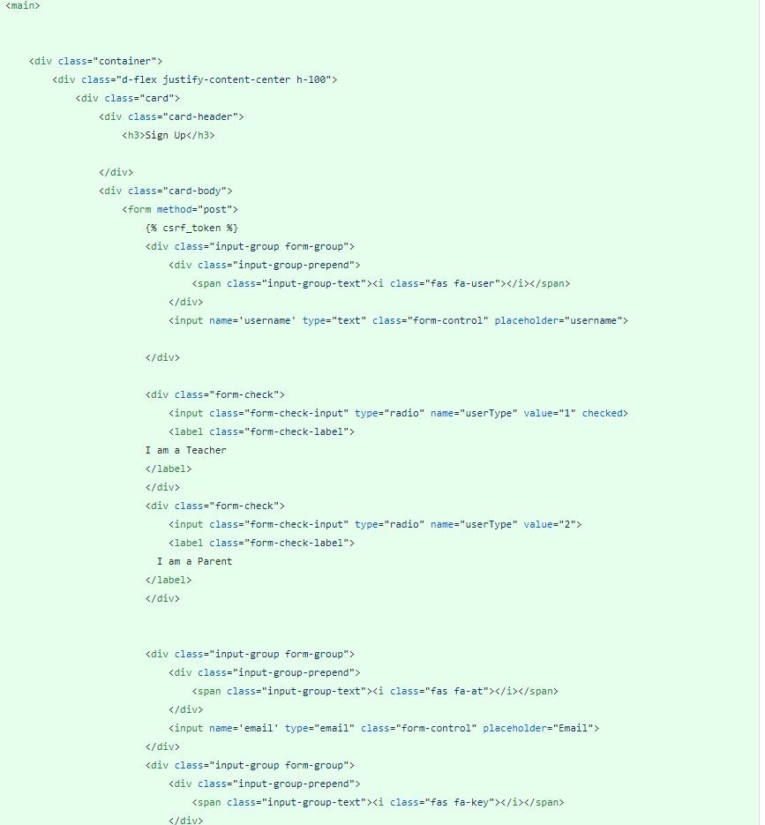

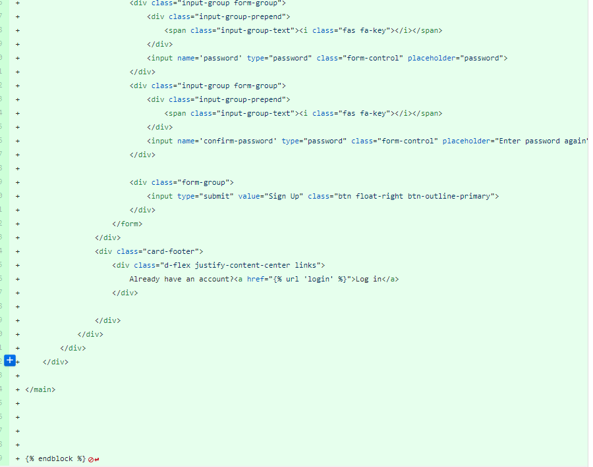

**Register CSS**

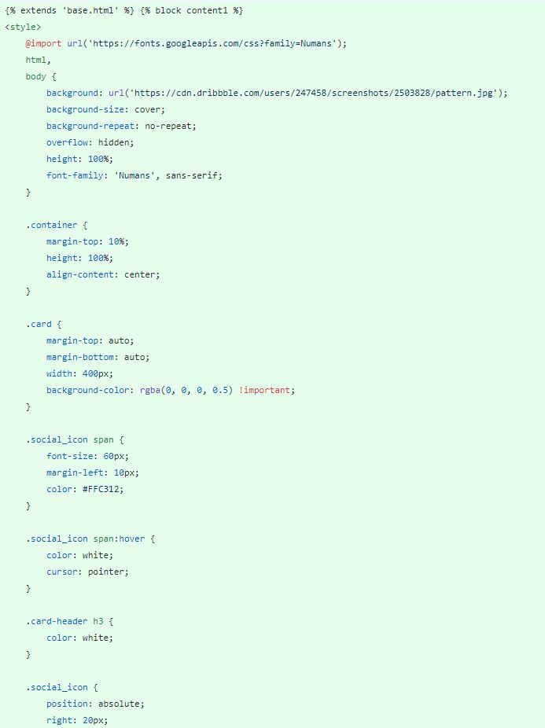

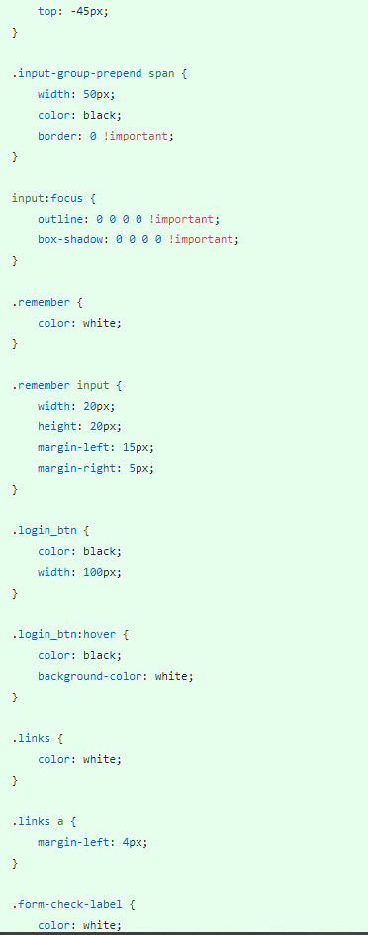

**Register Backend**

**Admin.py**

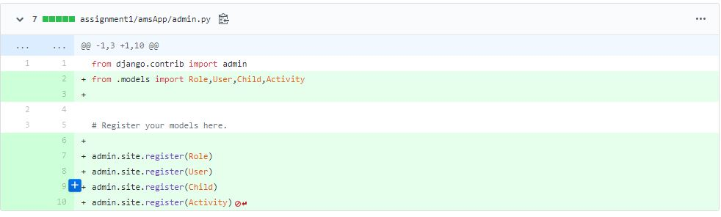

**Views.py**

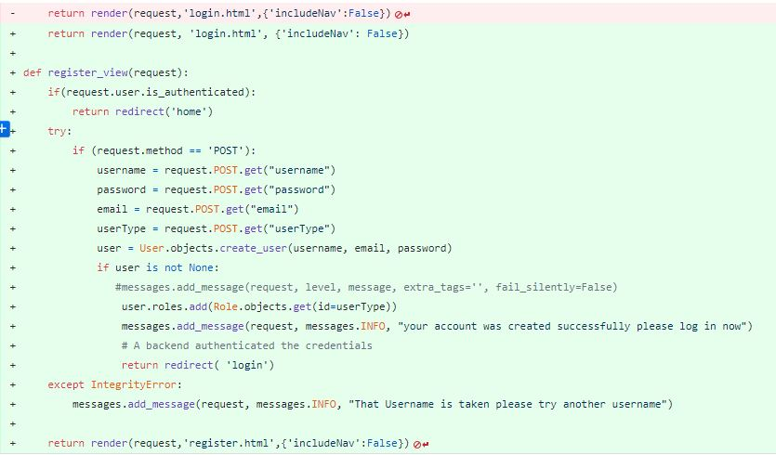

**Settings.py**

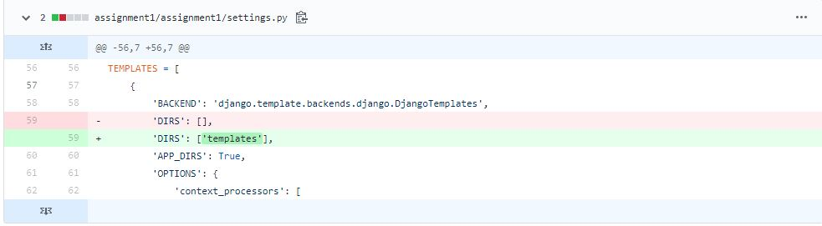

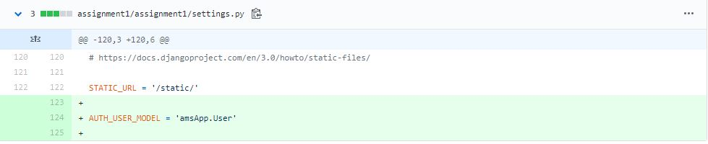

**Urls.py**

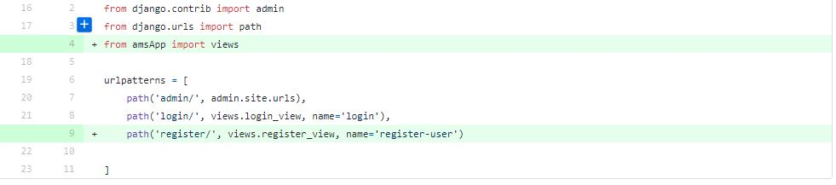

**Models.py ­­**

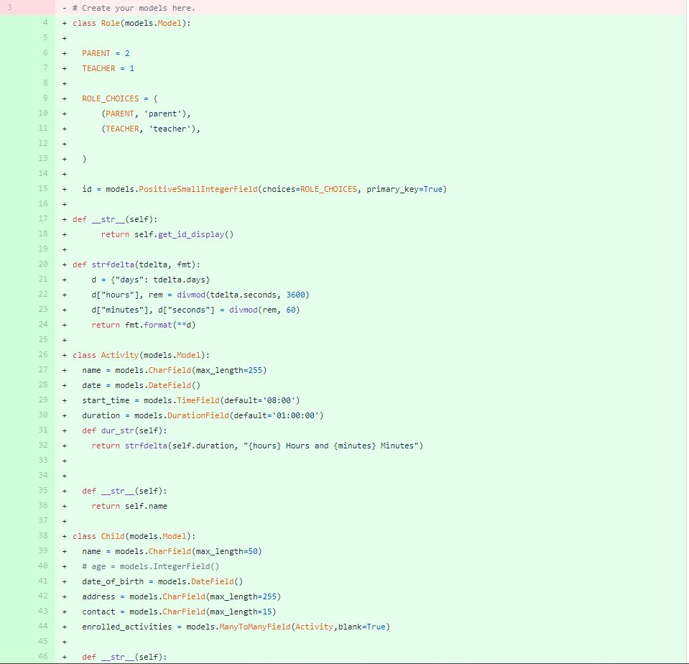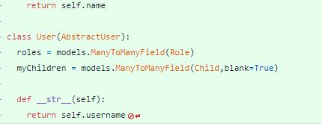

**Add import in views.py**

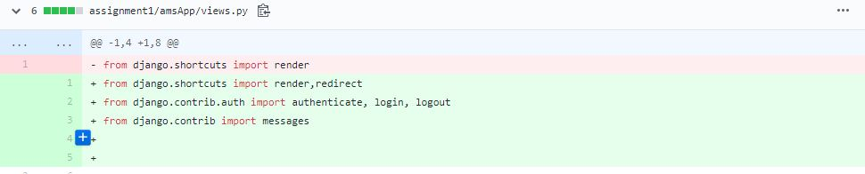

**Database created after migrating models**

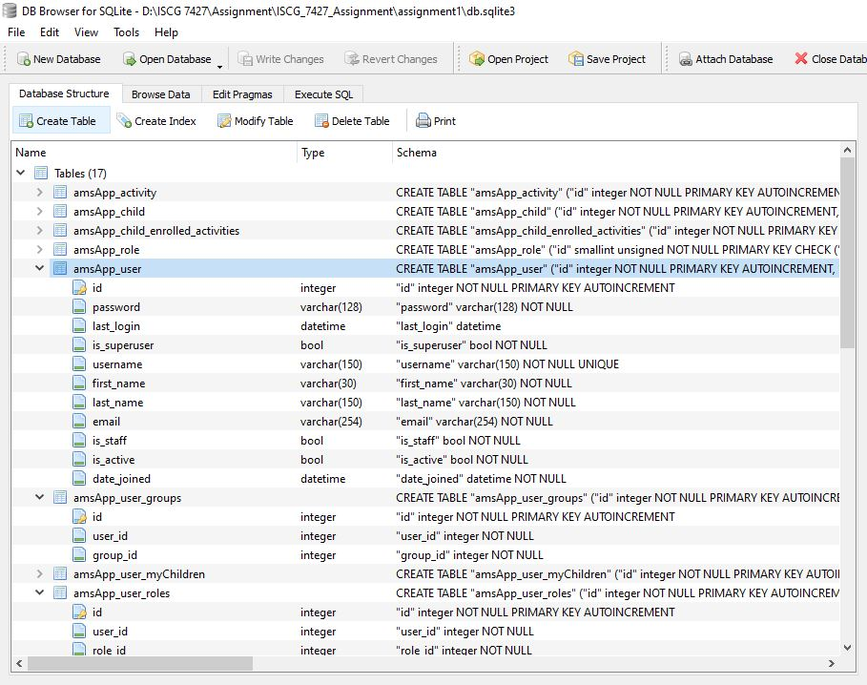

**Forms.py**

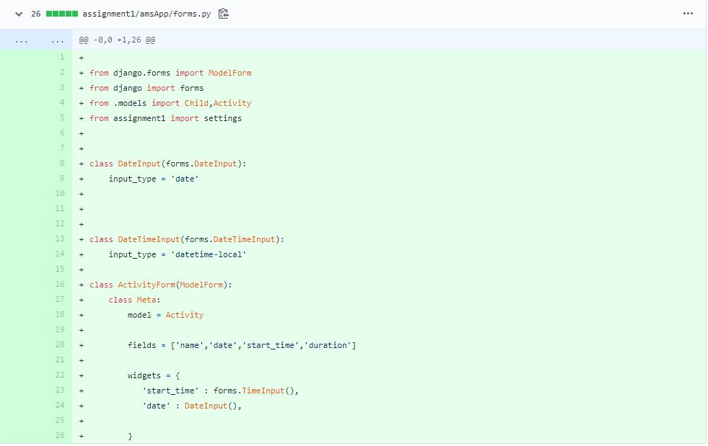

**Register Application Interface**

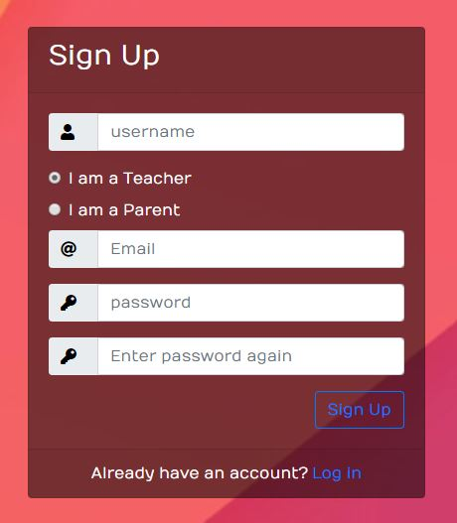

**Create Home.html**

**Acceptance Criteria**

* Home.html should contain a reference to user roles created in models.py. Parent = 1, Teacher = 2
* Home.html should contain the bootstrap “card” class and have the activity name, date, start time and duration in it.
* Button functionality should be enclosed inside curly brackets referencing the appropriate number for the parent user created in models.py

**Navigation html**

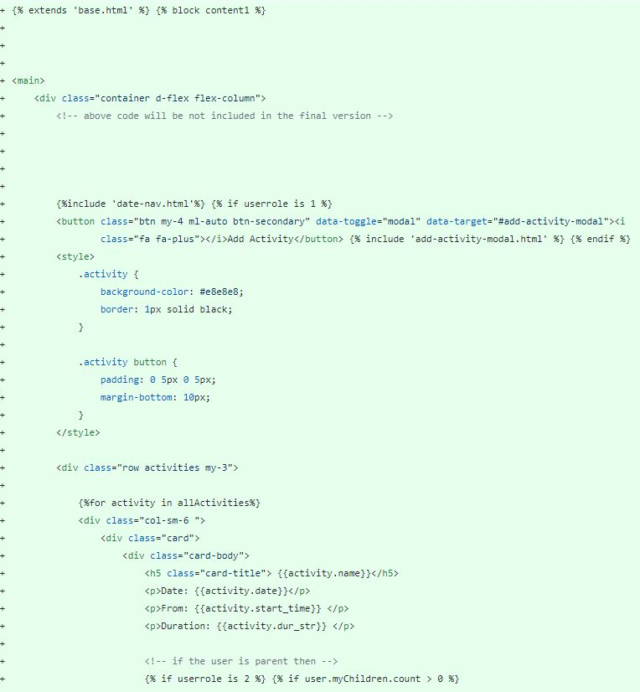

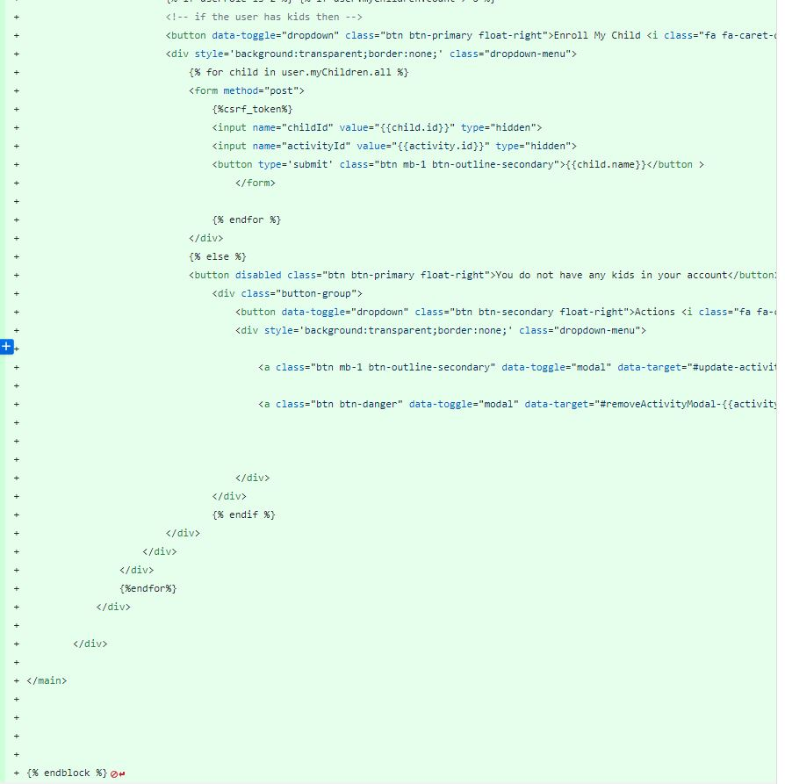



**Home screen html**

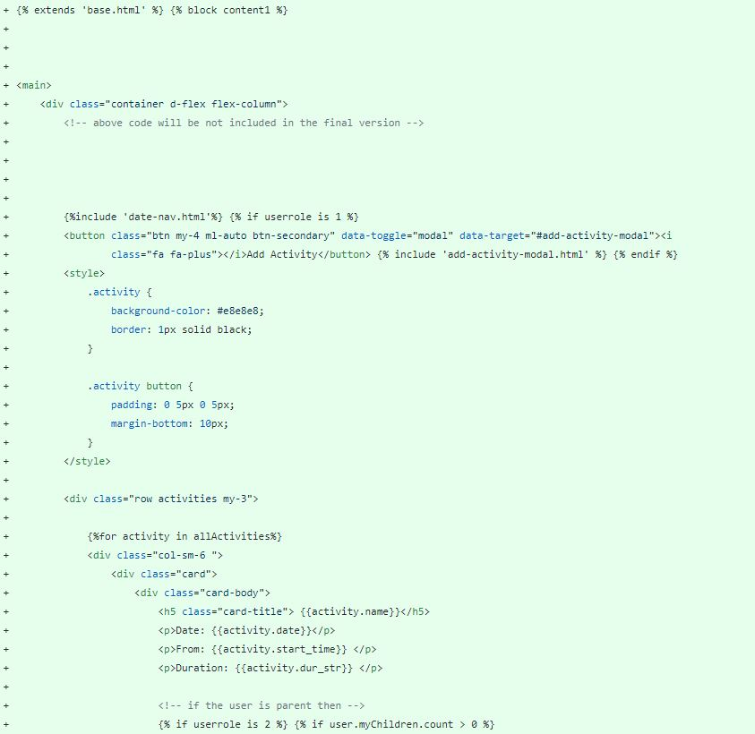

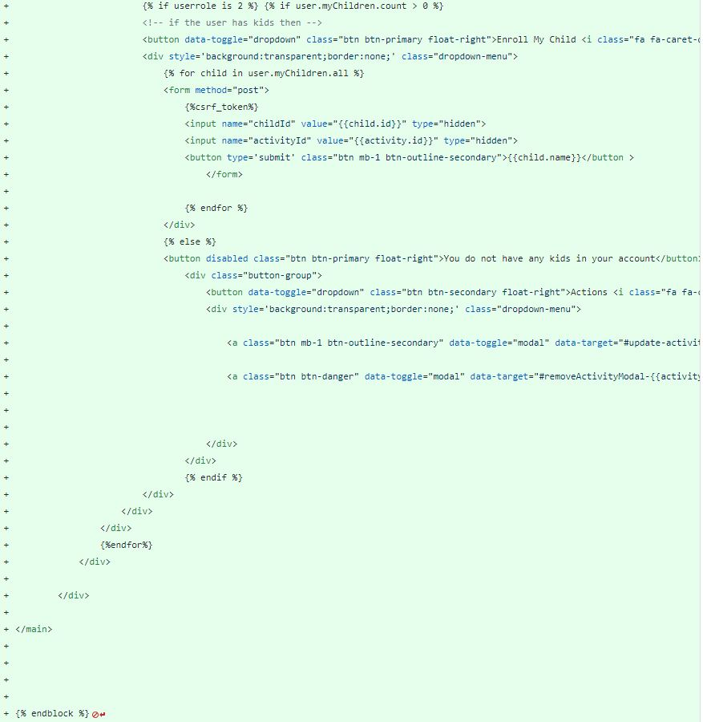

**Home Backend**

**Views.py**

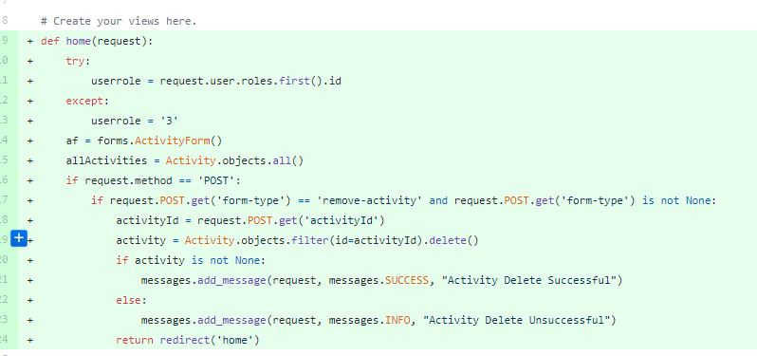

**Urls.py**



**Parent Homepage Application Interface**

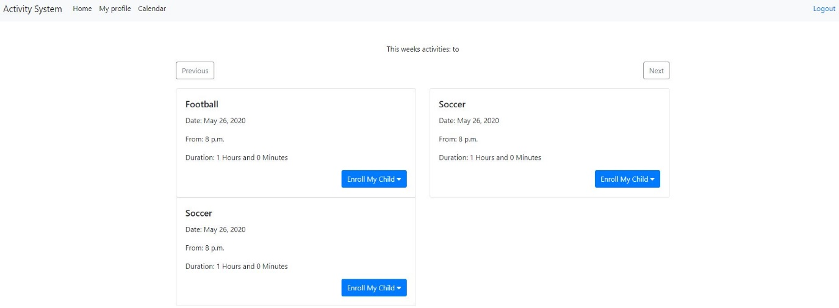

**Teacher Homepage Application Interface**

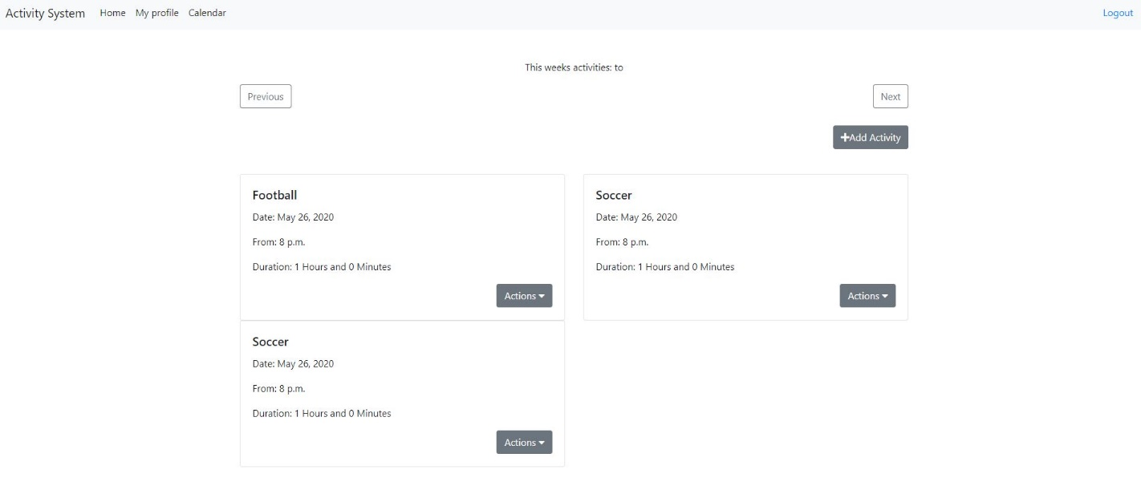

**Enroll Child HTML**

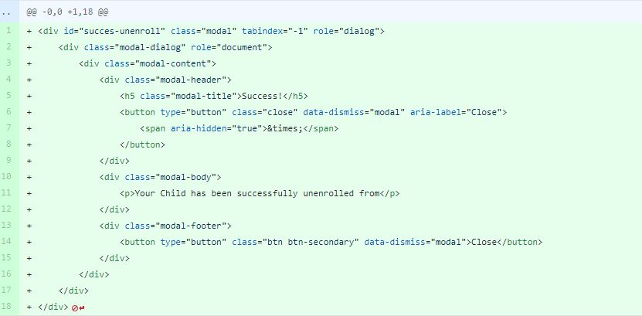

**Child-Profile HTML**

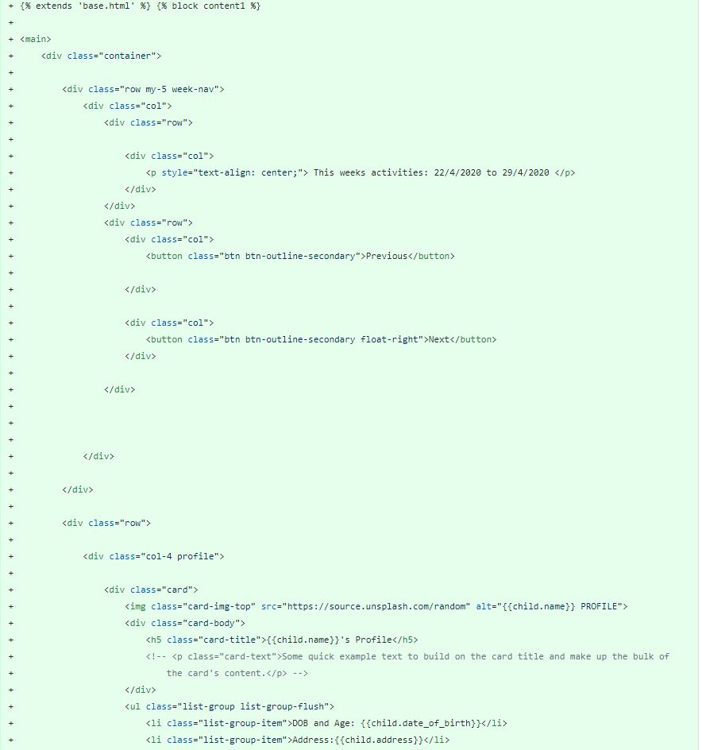

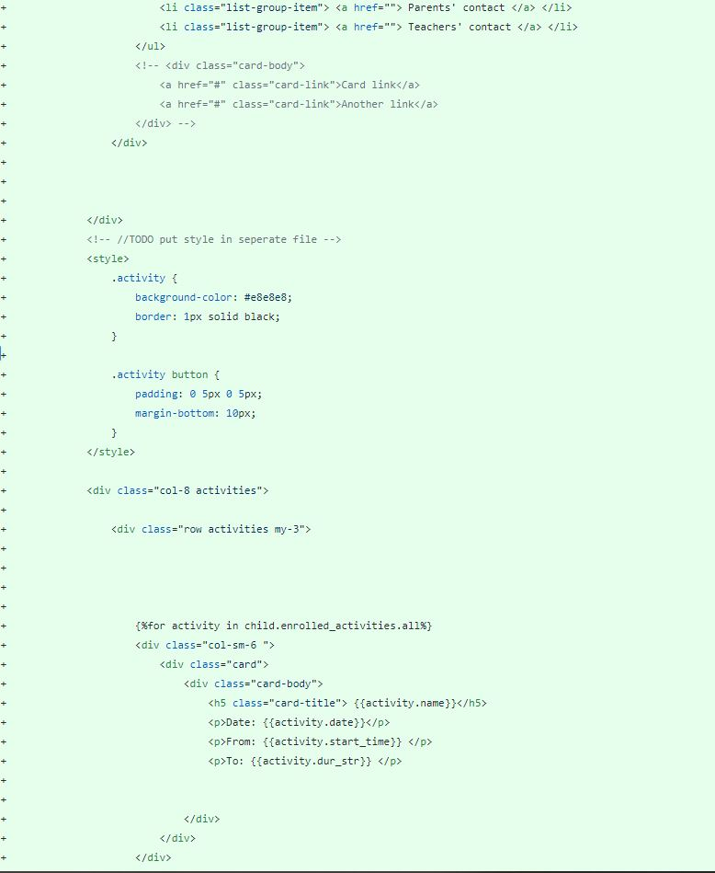

**Enroll child back end**

**Views.py**

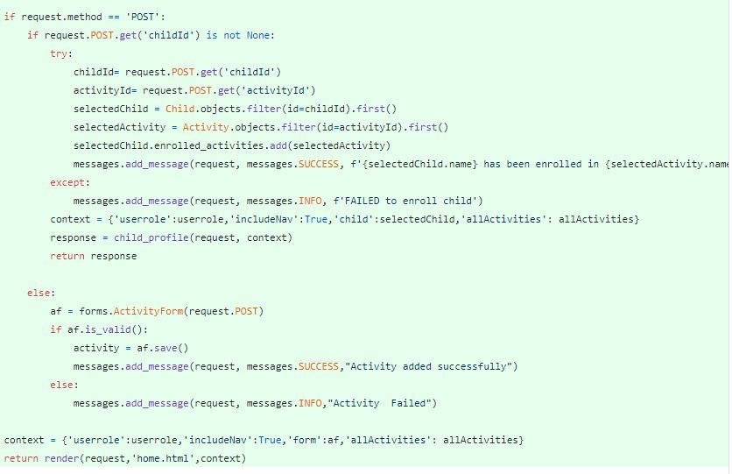

**Forms.py**

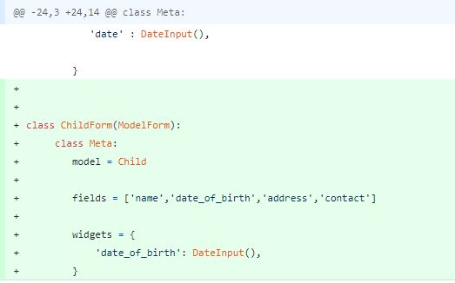

**Enroll Child Button**

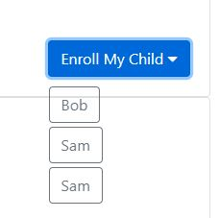

**Update Child HTML**

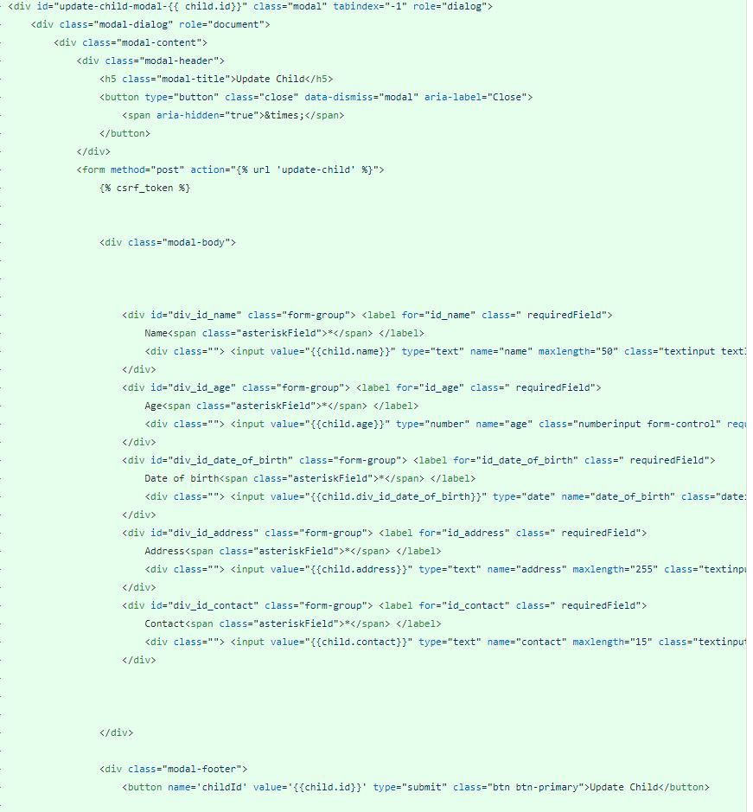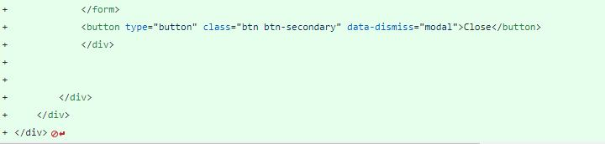

**Update-Child Backend**

**Views.py**

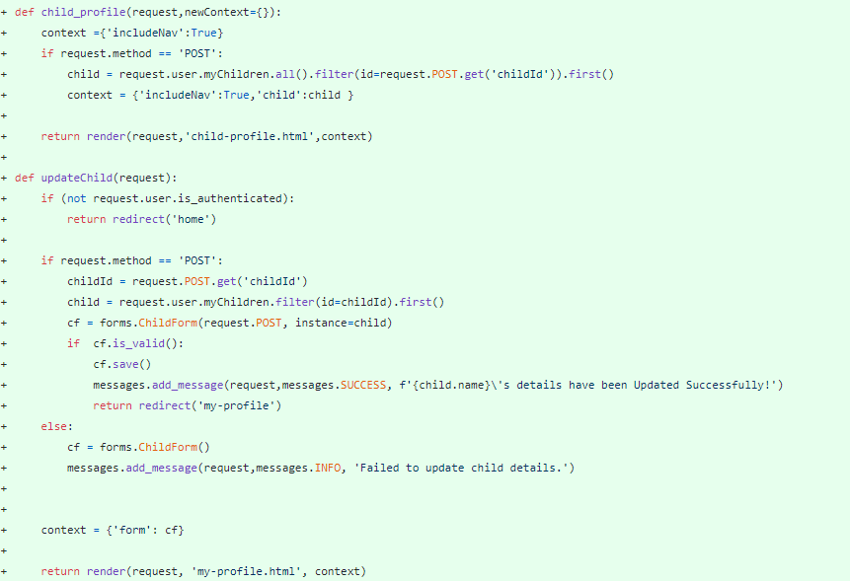

**Urls.py**



**Update-Child Application Interface**

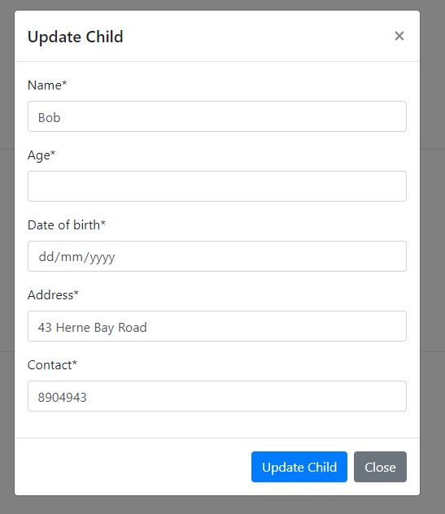

**Remove Child HTML**

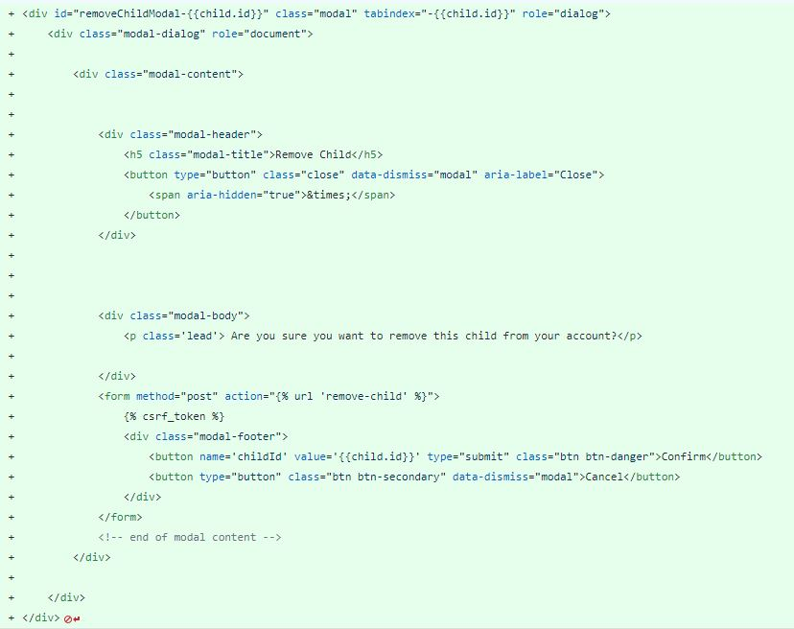

**Remove Child Back End**

**Views.py** 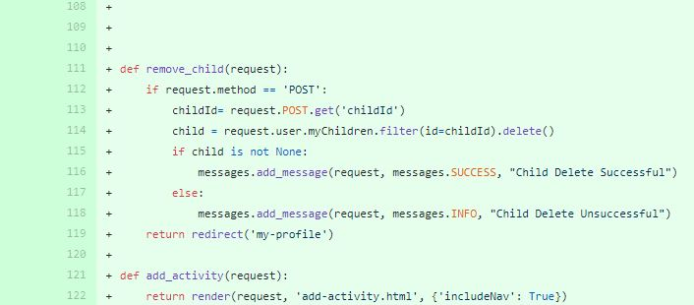

**Urls.py**



**Delete Child Application Interface**

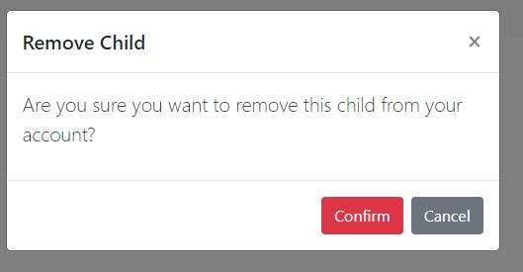

**Stand up Meetings**

We Plan do 20 meetings (about two meeting a week)

PS：Zoom in to see a clear image.

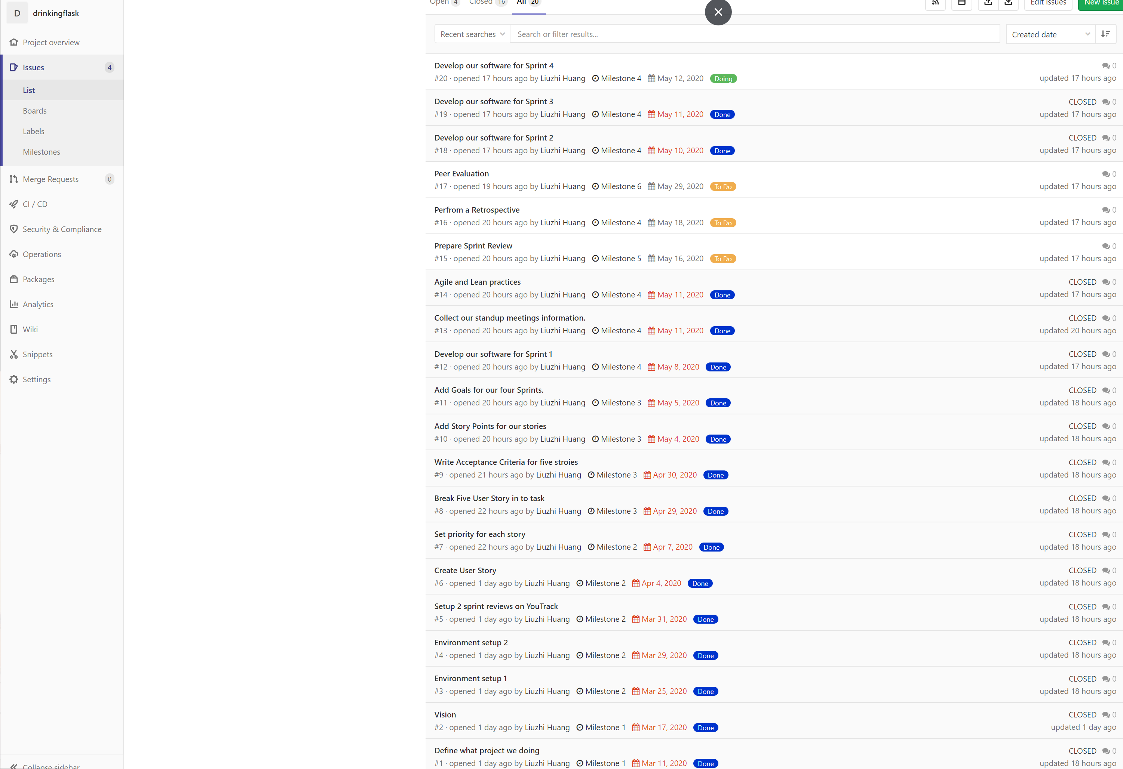

Milestone 1 Stand up Meetings

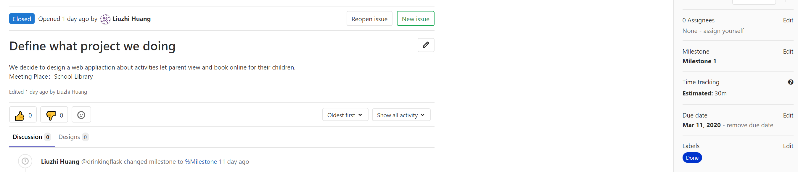

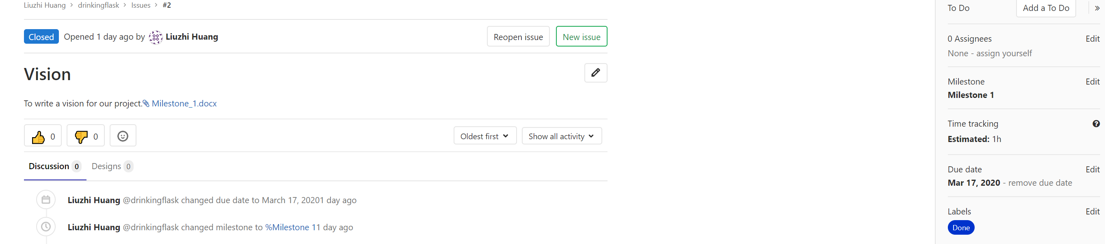

Milestone 2 Stand up Meetings

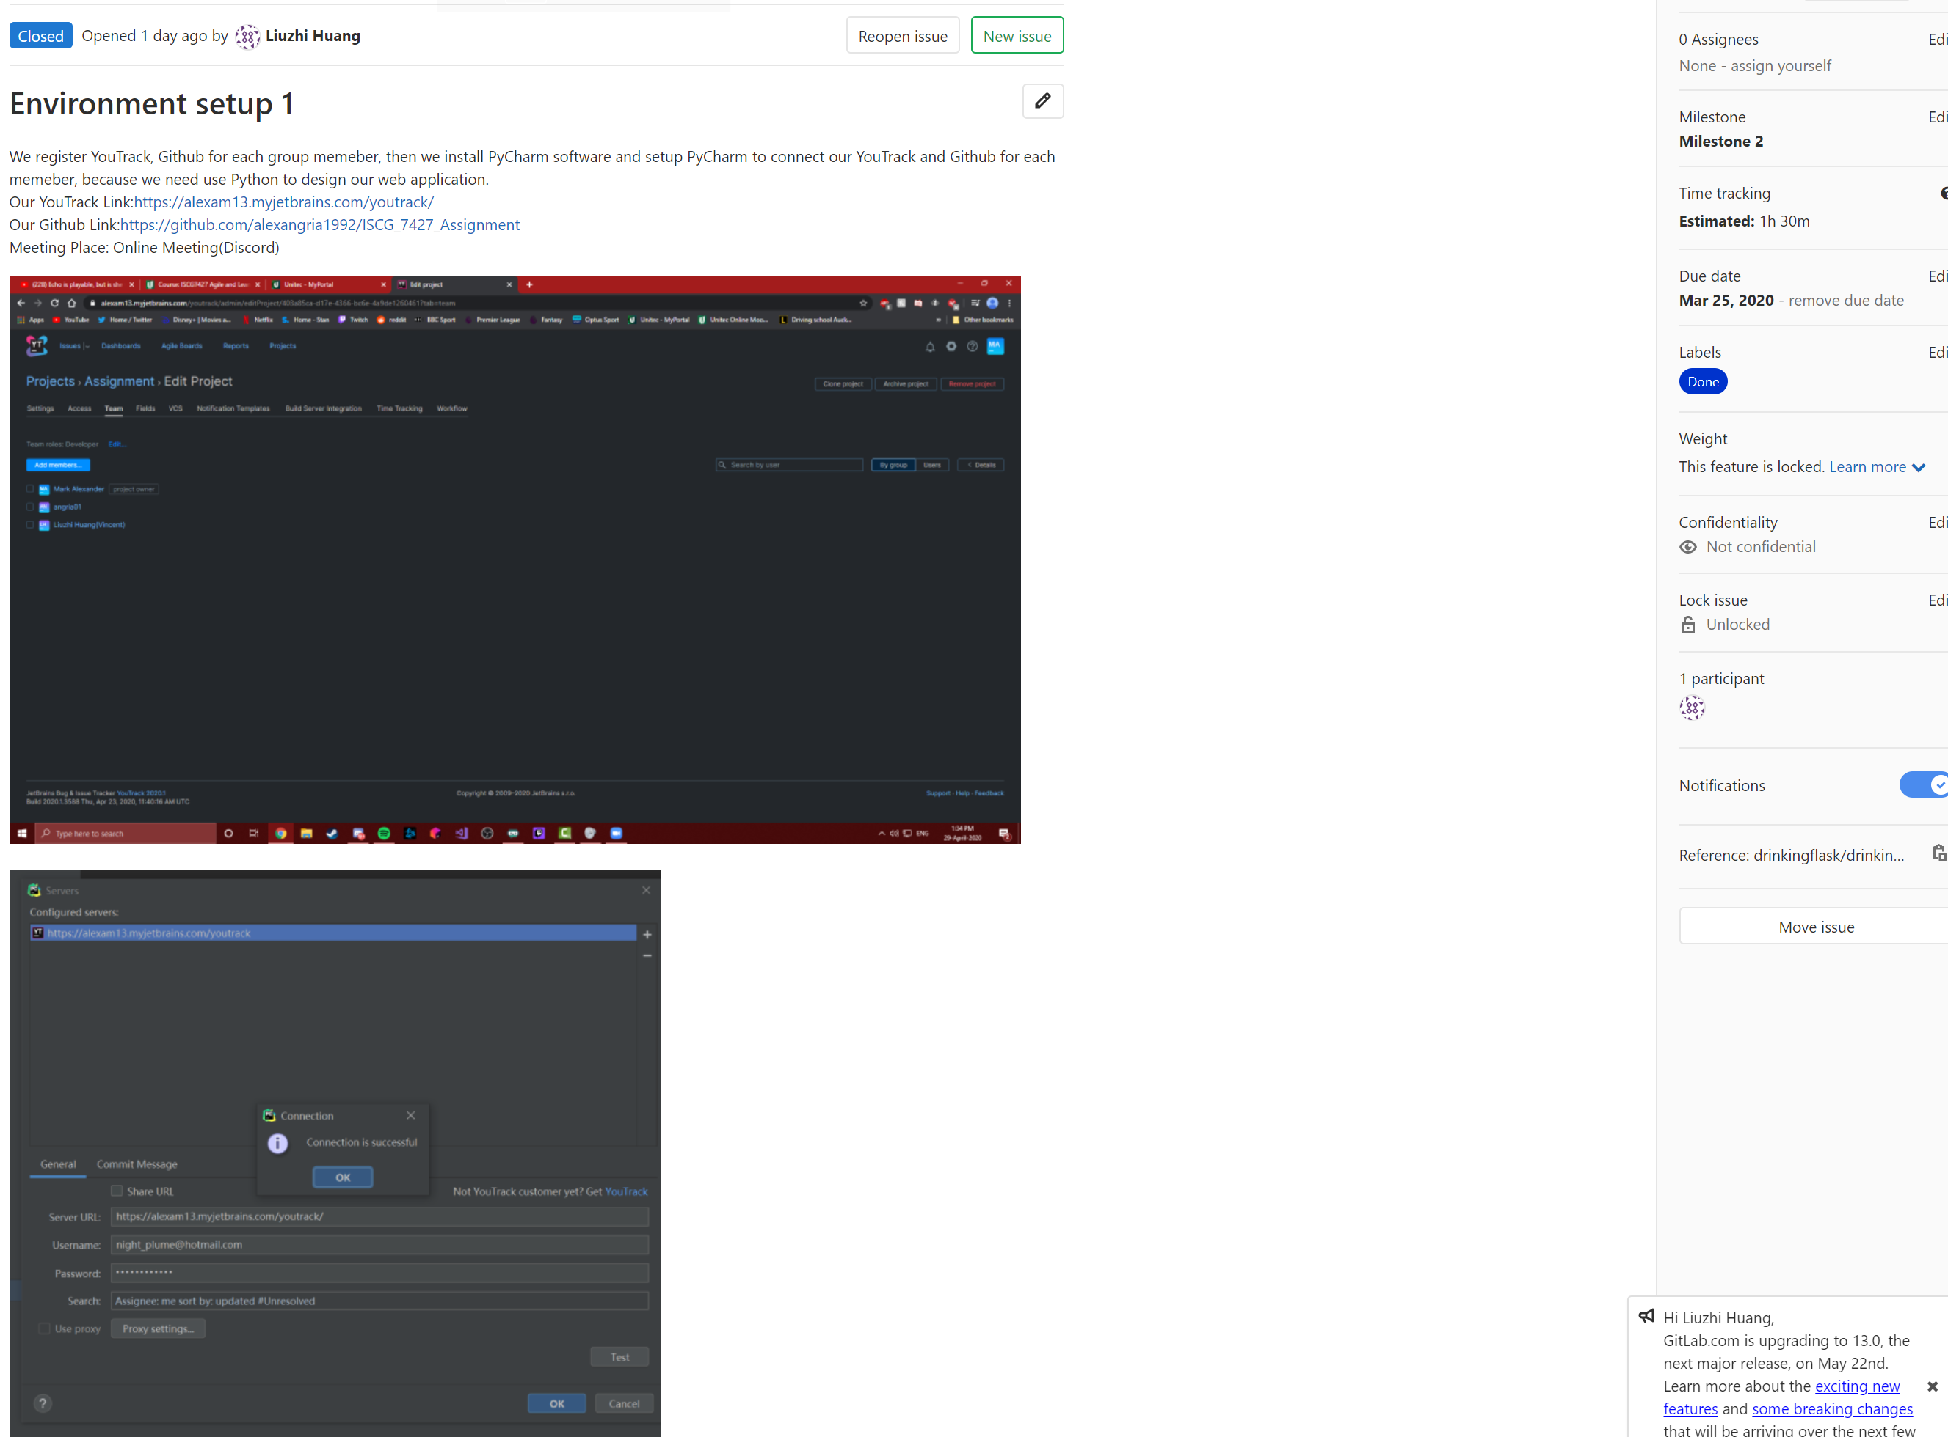

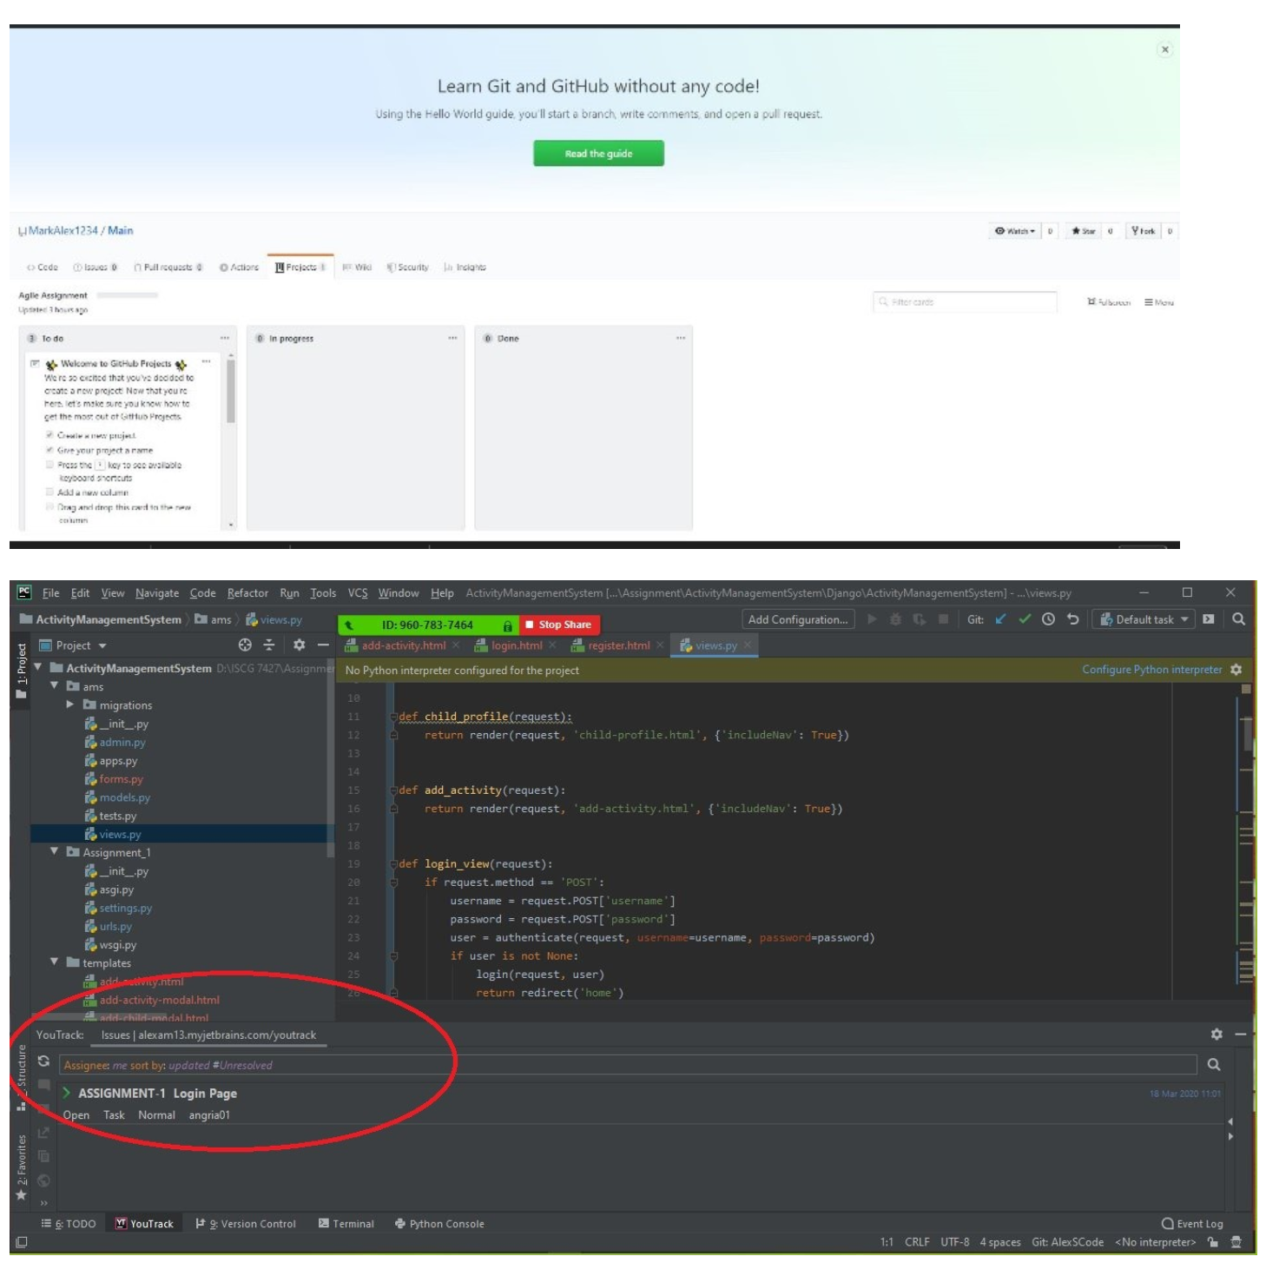

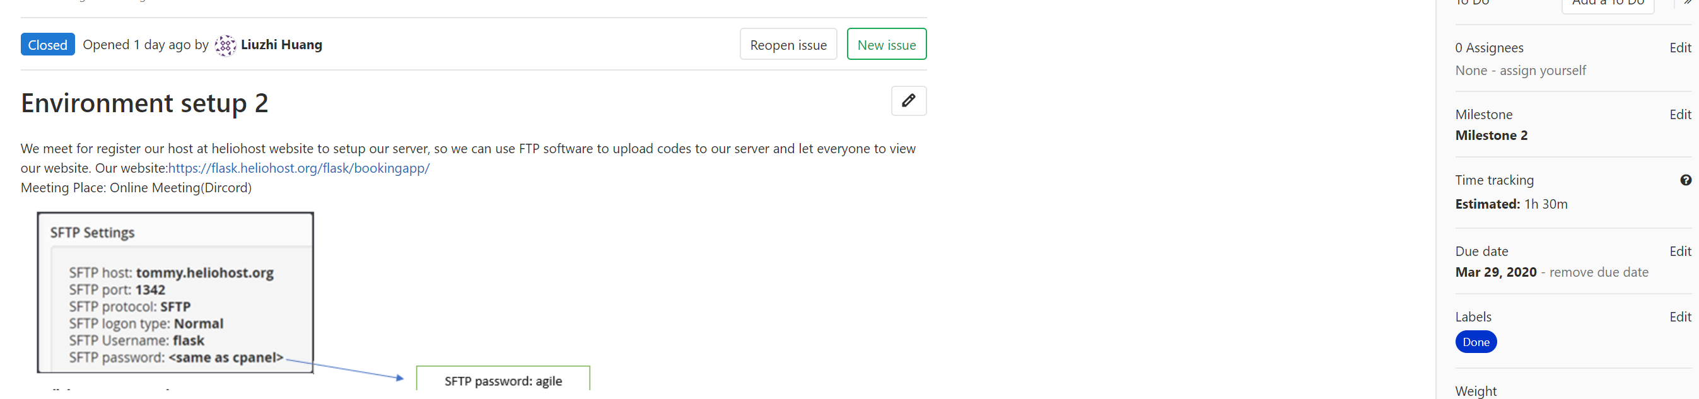

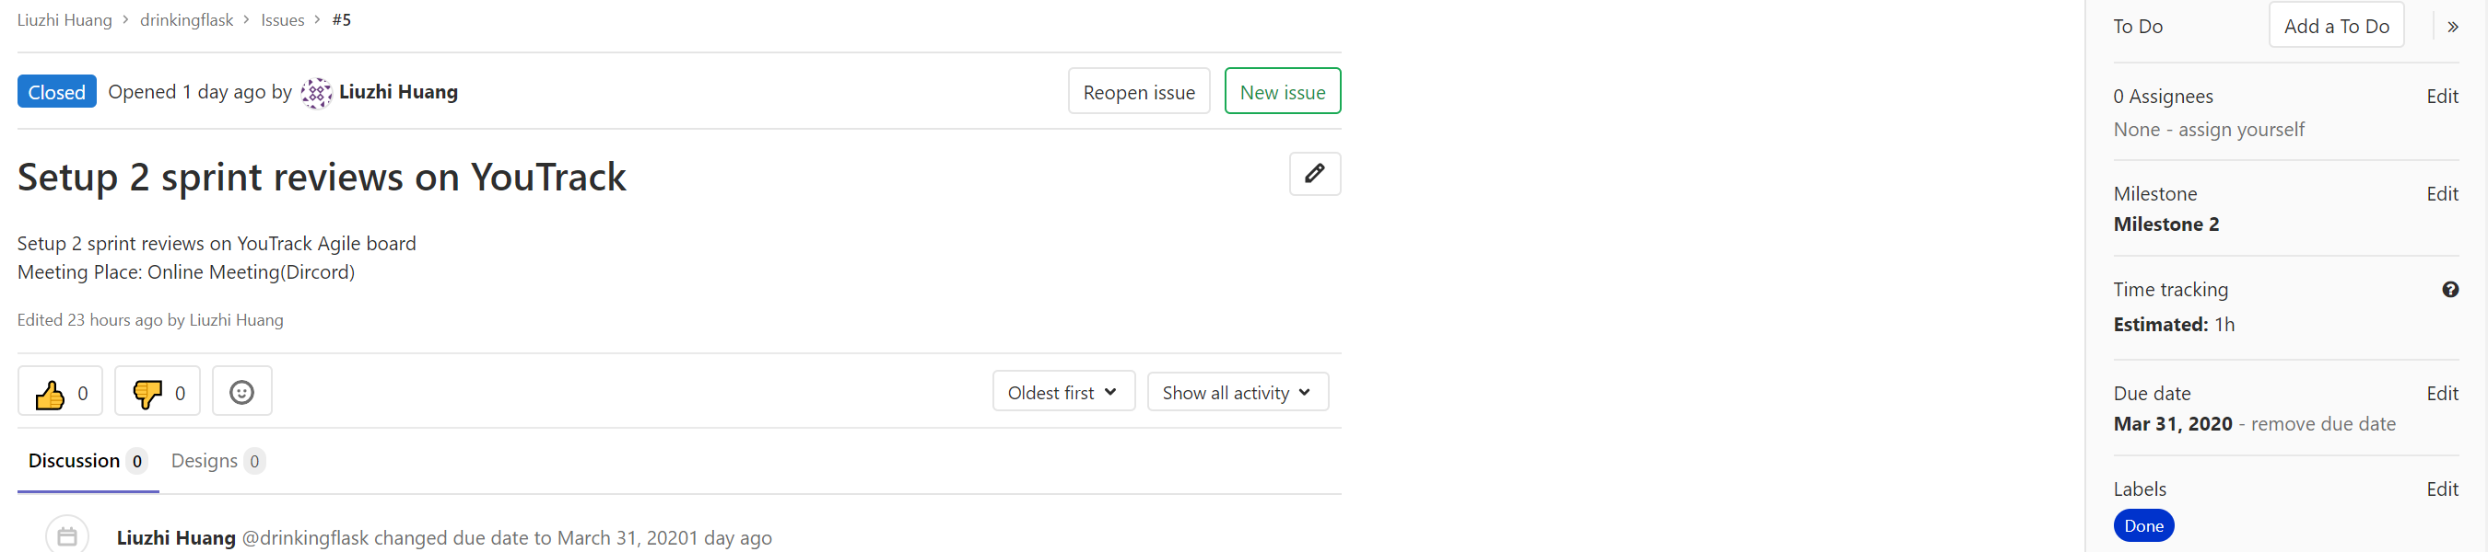

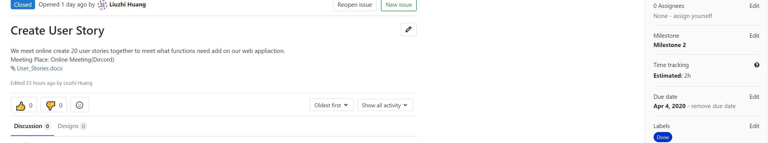

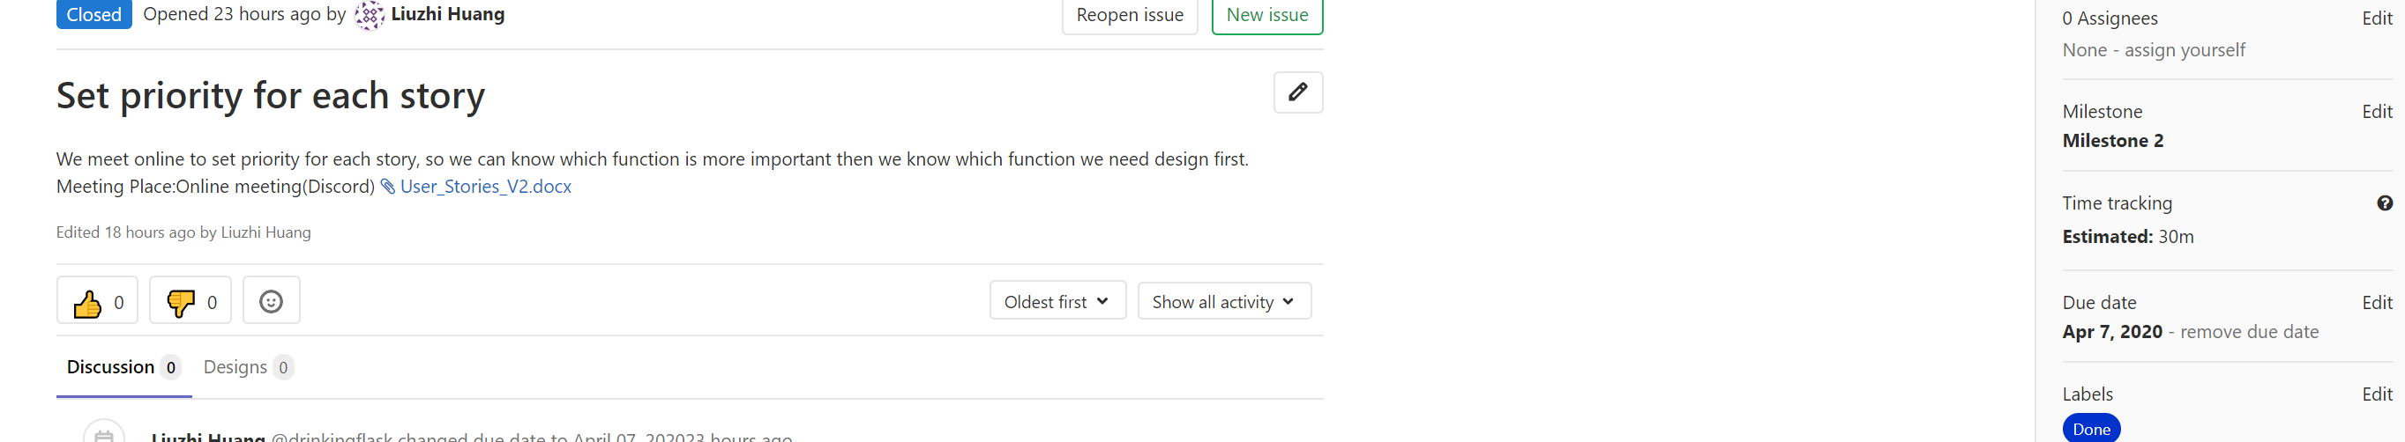

Milestone 3 Stand up Meetings

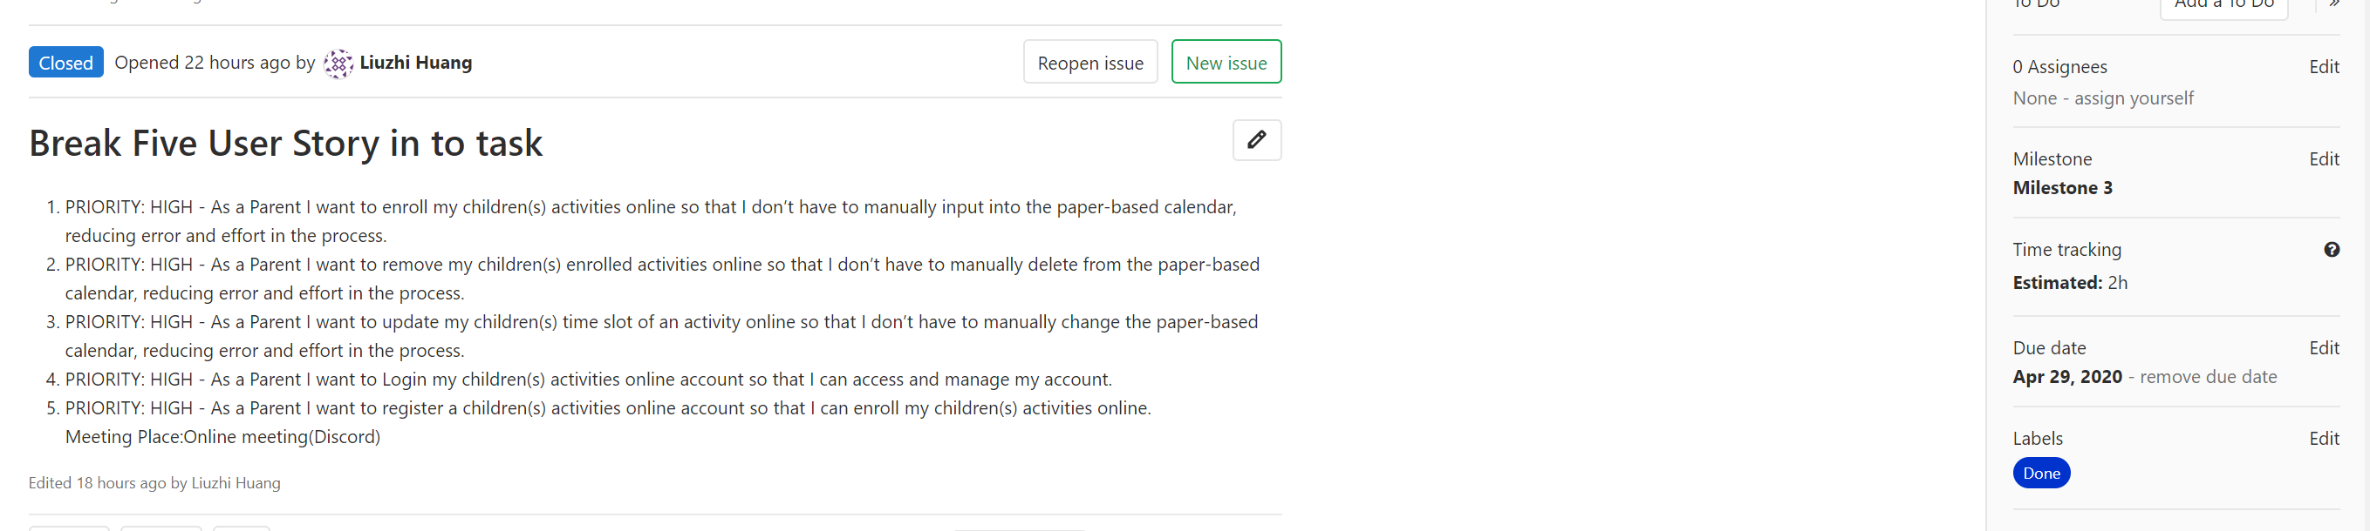

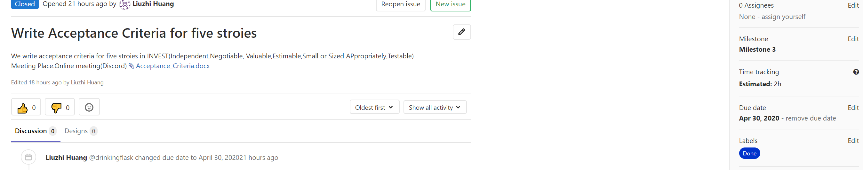

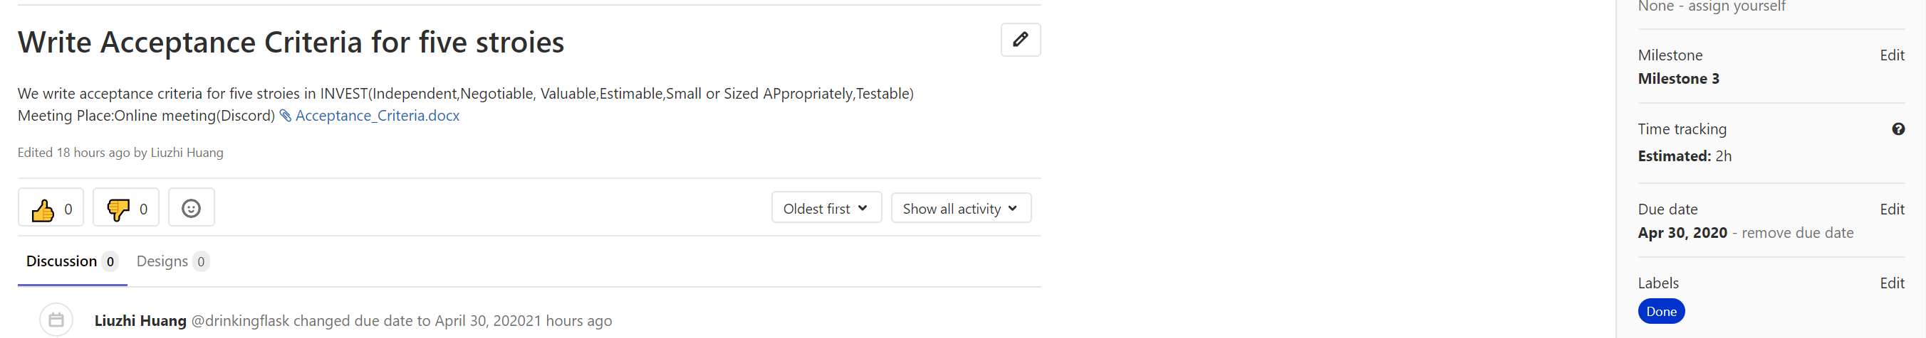

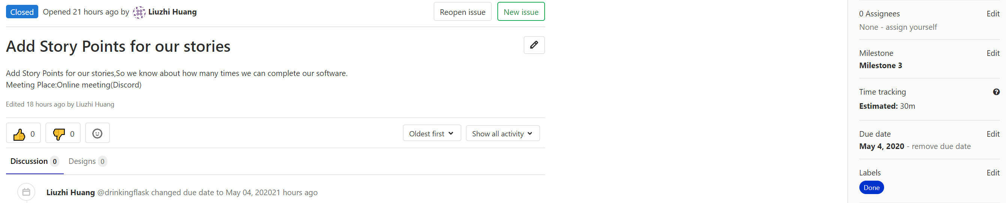

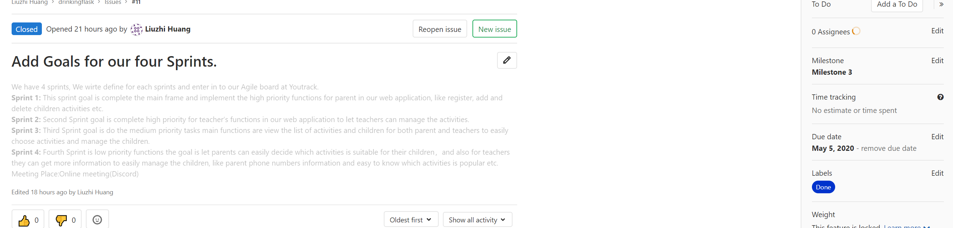

Milestone 4 Stand up Meetings

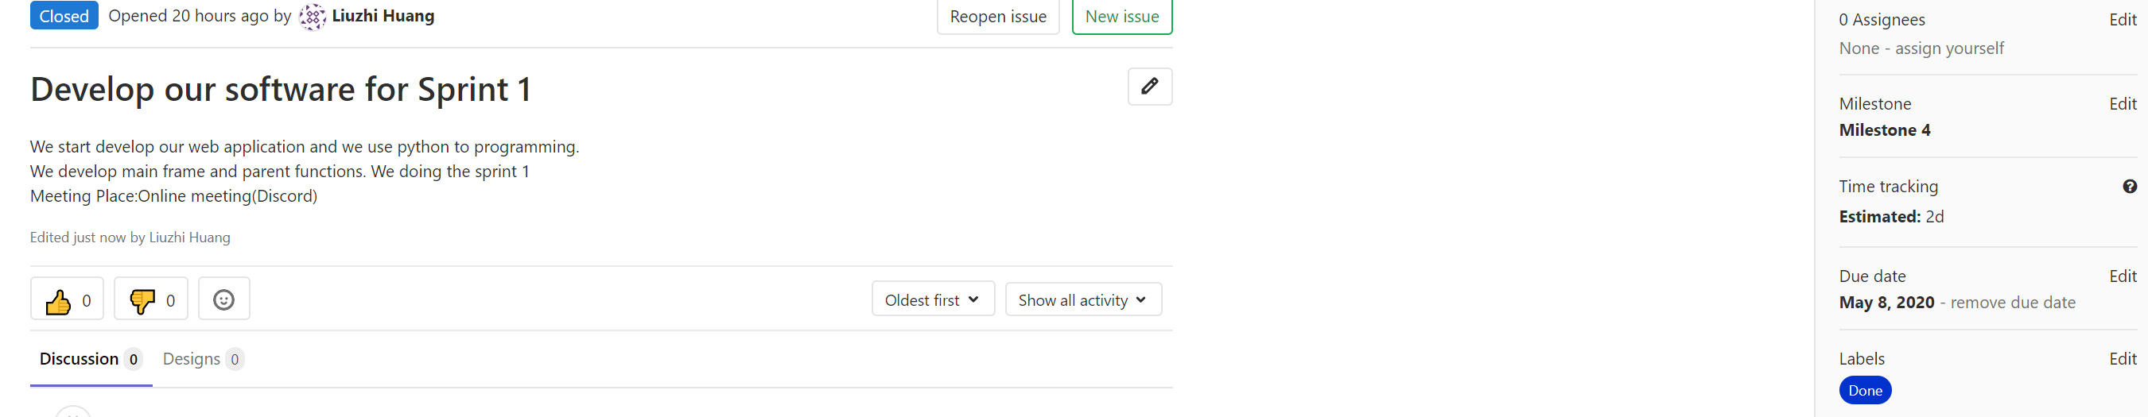

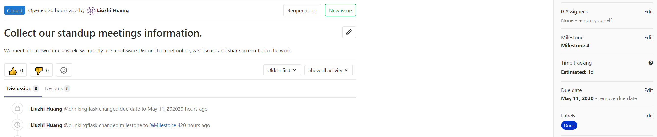

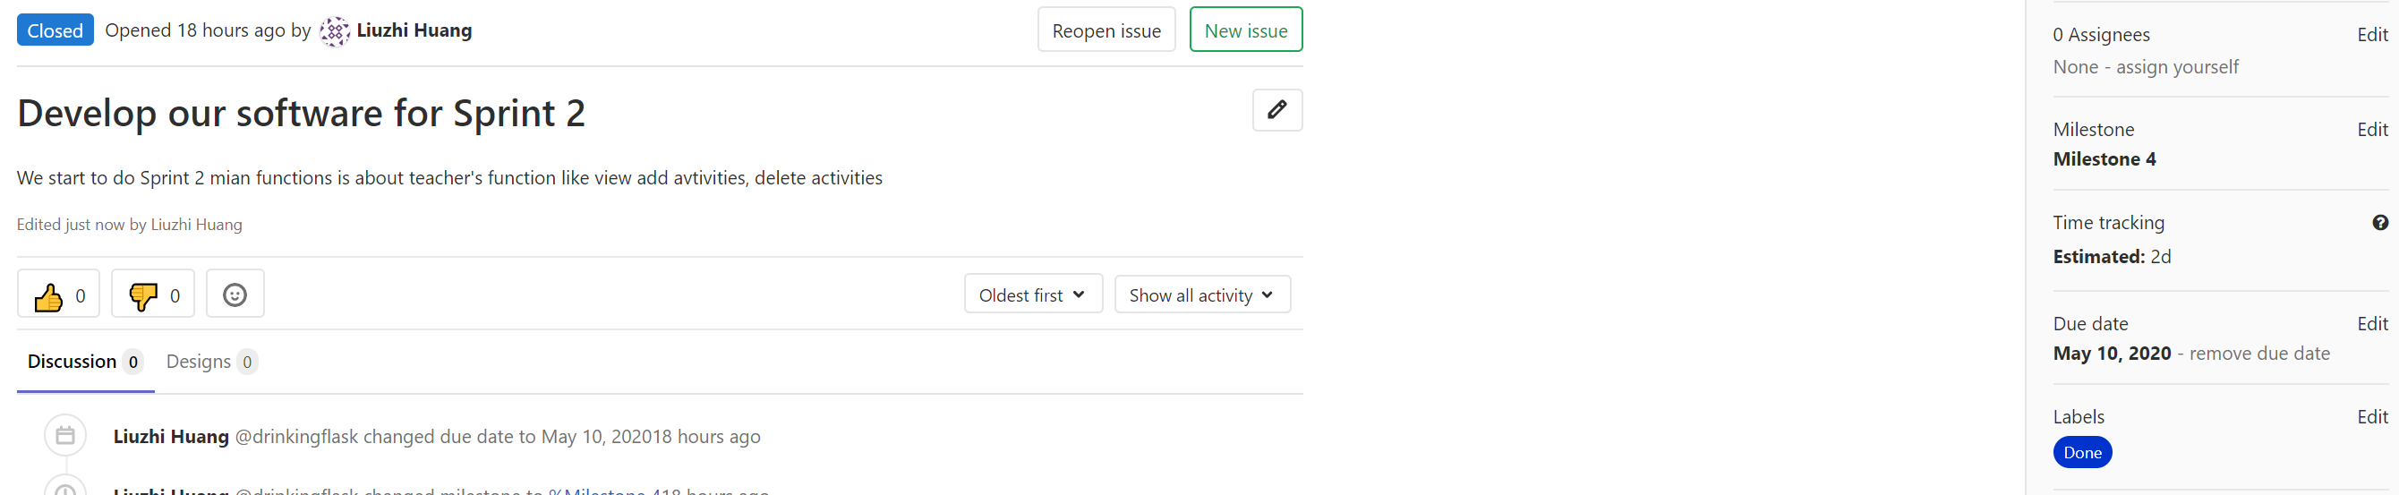

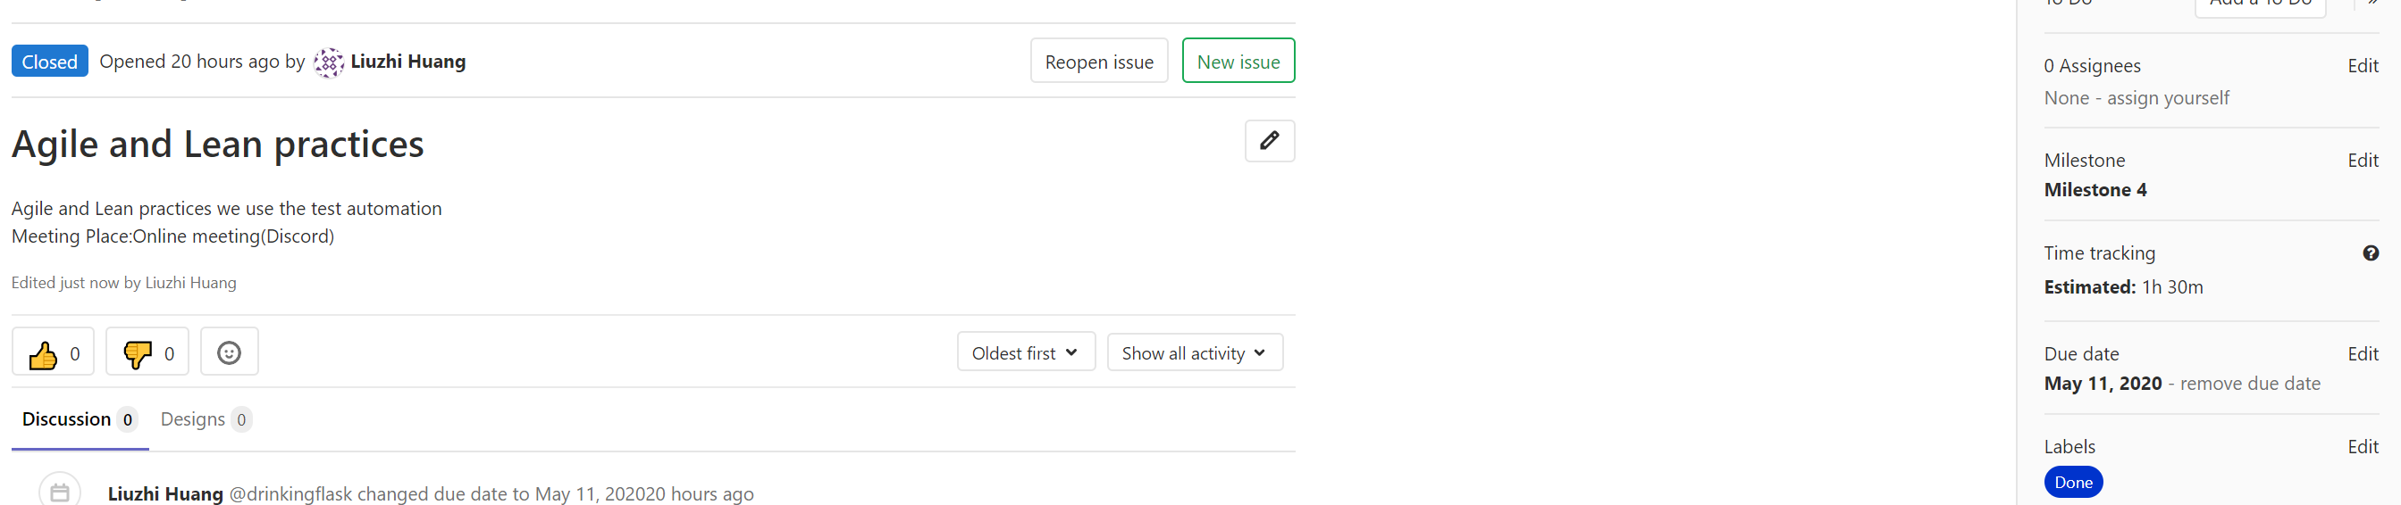

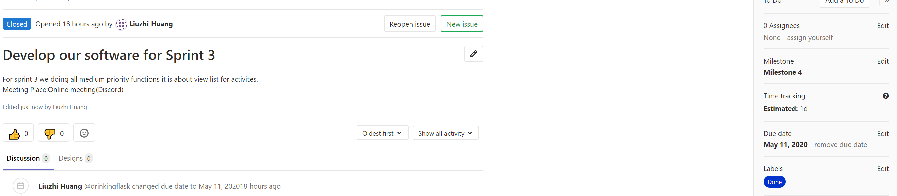

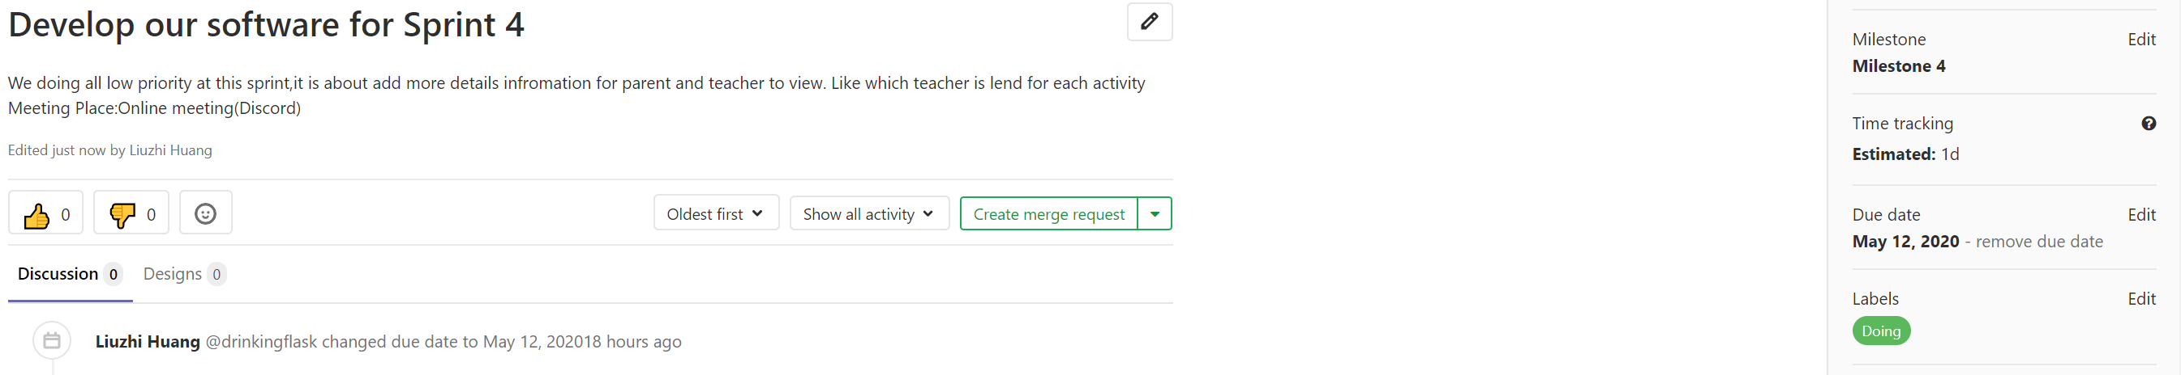

Milestone 5 Stand up Meetings (future meeting)

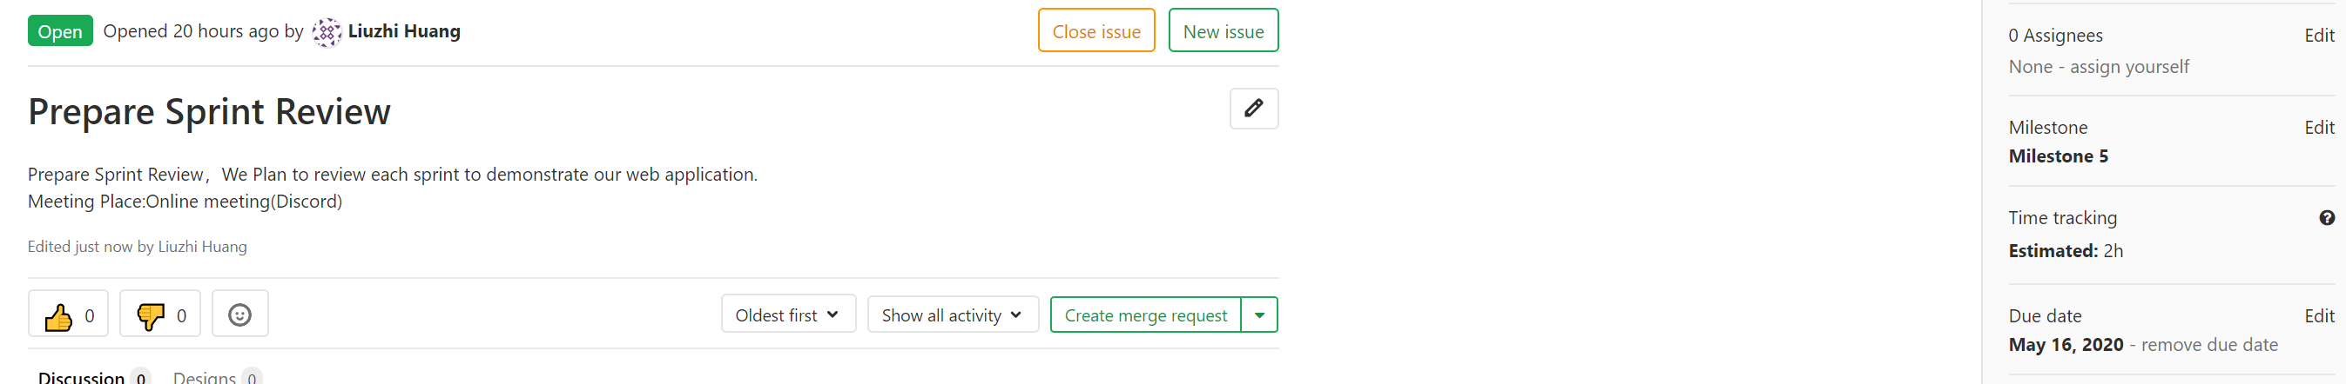

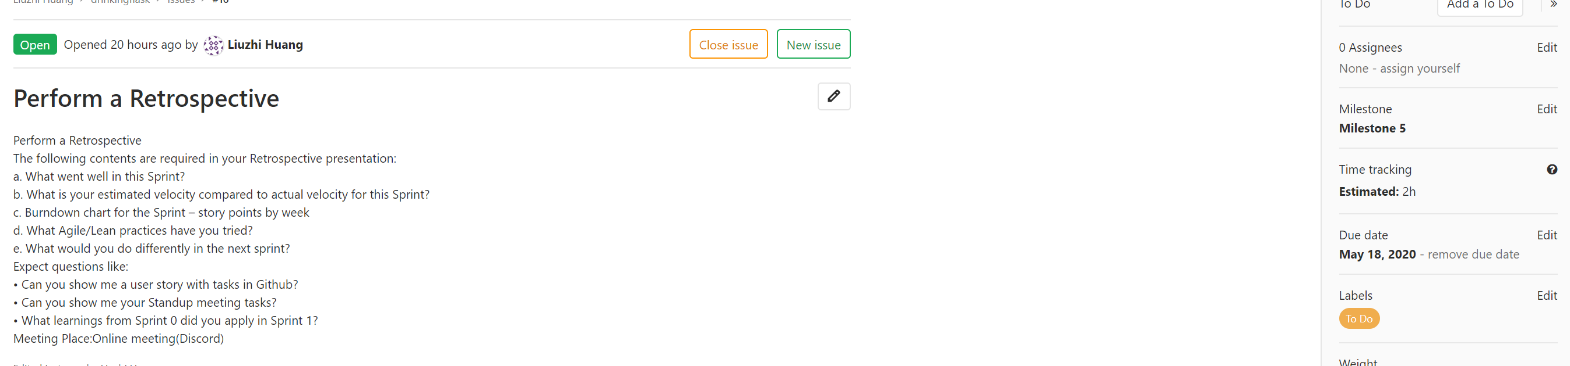

Mileston6 Stand up Meeting (future meeting)

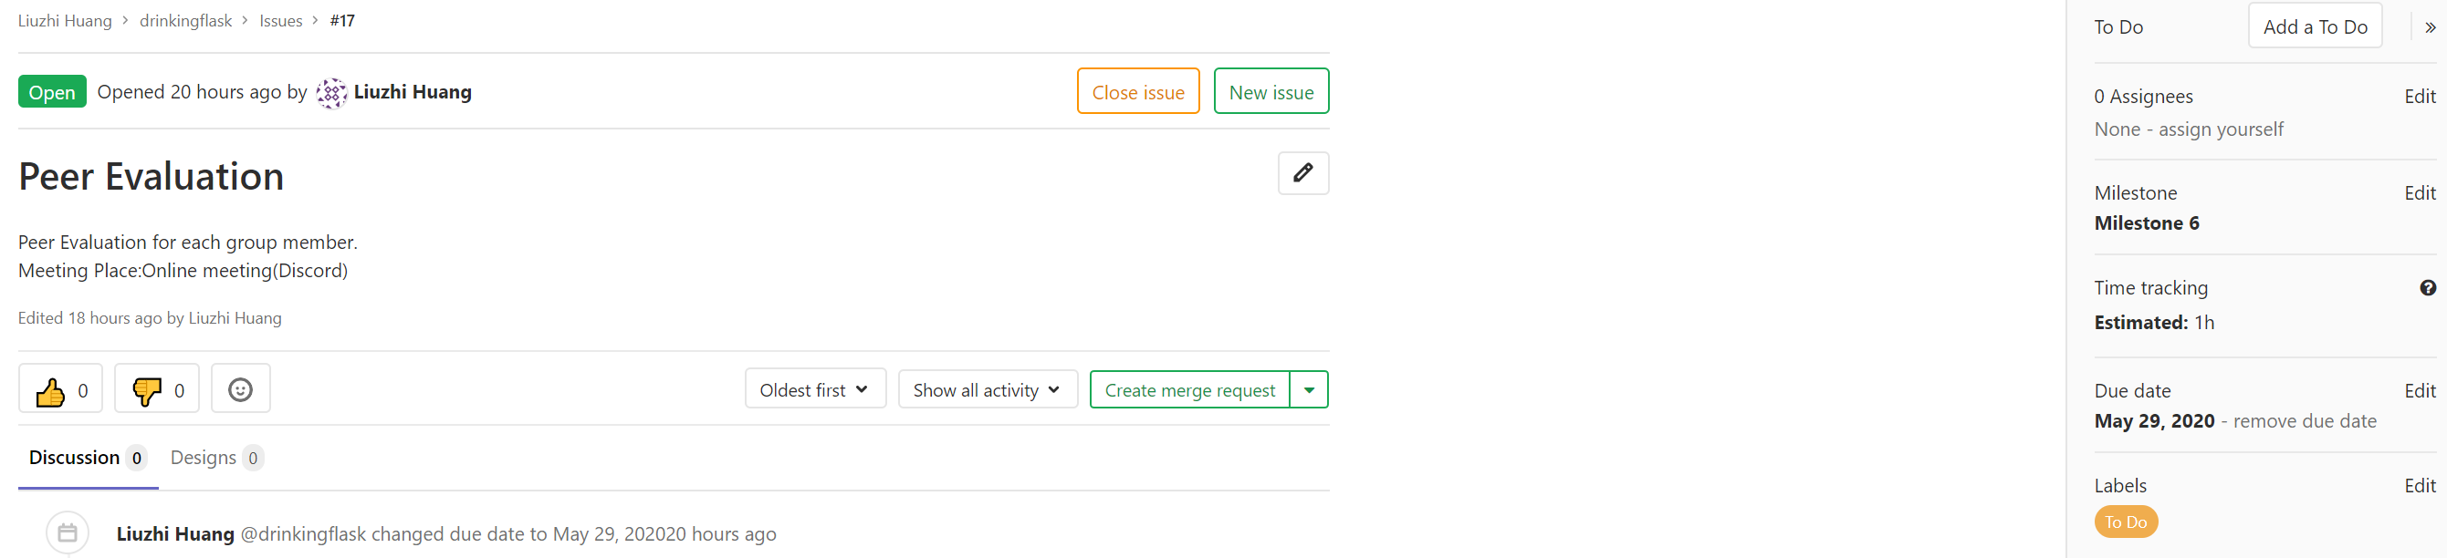

**Agile and Lean Practices**

The agile development model integrates testing into the entire development process and no longer treats it as an independent stage. Simply put, agile testing is continuous feedback and response to software quality issues in a timely manner.

So, we decide to use test automation, automated testing is absolutely dominant in agile testing. In the agile development model, it is urgent to require a high degree of automation of the test. An iteration is usually two or three weeks, which means that we only have two or three Days to complete the entire test process of the entire project. Without automation, there is no agile. In the agile testing process, it is mainly divided into the following main testing stages:

Unit Test (UT)

It is to test the correctness of the program module (the smallest unit of software design). The program unit is the smallest testable part of the application. In procedural programming, a unit is a single program, function, process, etc. For object-oriented programming, the smallest unit is a method, including methods in a base class (superclass), abstract class, or derived class (subclass).

Integration Test (IT)

Integration testing is also called assembly testing, that is, the program modules are assembled in a one-time or value-added manner to test the correctness of the interface of the system. Integration testing is generally performed after unit testing and before system testing. Practice has shown that sometimes modules can work alone, but there is no guarantee that they can work simultaneously when assembled.

User Acceptance Test (UAT)

User acceptance test, also known as user acceptance test, is generally in the final stage of the project process. At this time, relevant product managers, business personnel, users or testers test and accept the system according to the test plan and results to decide whether to accept the system. It is a test to determine whether the product can meet the requirements specified by the contract or the user.

Regression Test

Regression testing is a type of software testing designed to check whether the original functions of the software remain intact after modification. Regression testing is mainly for the purpose of checking degradation. Degradation mainly refers to the phenomenon that due to the update of the system version, the function that normally worked in the previous version becomes unable to operate normally, or an issue is urgently fixed, but it causes other problems.

**Selenium Automated Tests**

**Invalid Login**

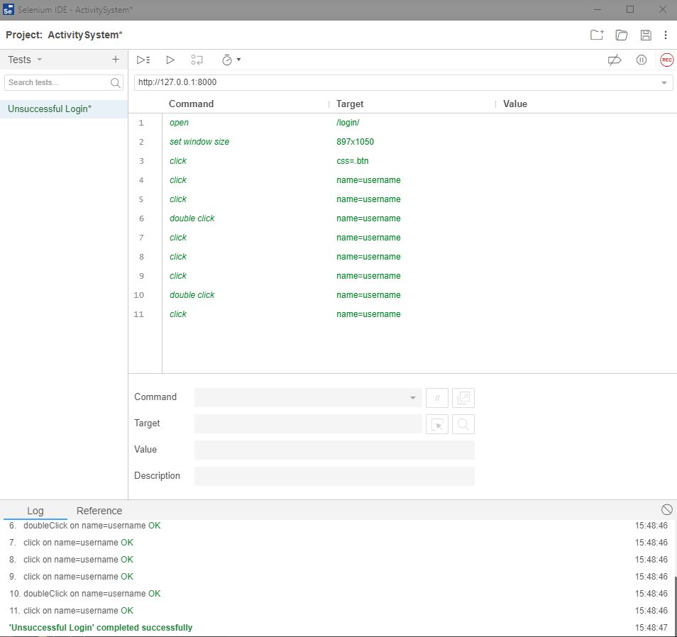

**Test Case**

|  |  |  |  |  |
| --- | --- | --- | --- | --- |
| Test case ID | Requirements | Input test data | Expected outcomes | Actual outcomes |
| TC01 | Check if elements are on the login page | <http://127.0.0.1:8000/login/> | “username” field is present  “password” field is present | As expected |
| TC02 | User is authenticated correctly | username = “parent40”  password = “1234”  Click “Login” | Error Message: “Please check your username and password.” | As expected |
| TC03 | Username and password are blank | username = “”  password = “”  Click “Login” | Error Message: “Please check your username and password.” | As expected |
| TC04 | Username is blank | username = “”  password = “1234”  Click “Login” | Error Message: “Please check your username and password.” | As expected |
| TC05 | password is blank | username = “parent40”  password = “”  Click “Login” | Error Message: “Please check your username and password.” | As expected |

**Successful Login**

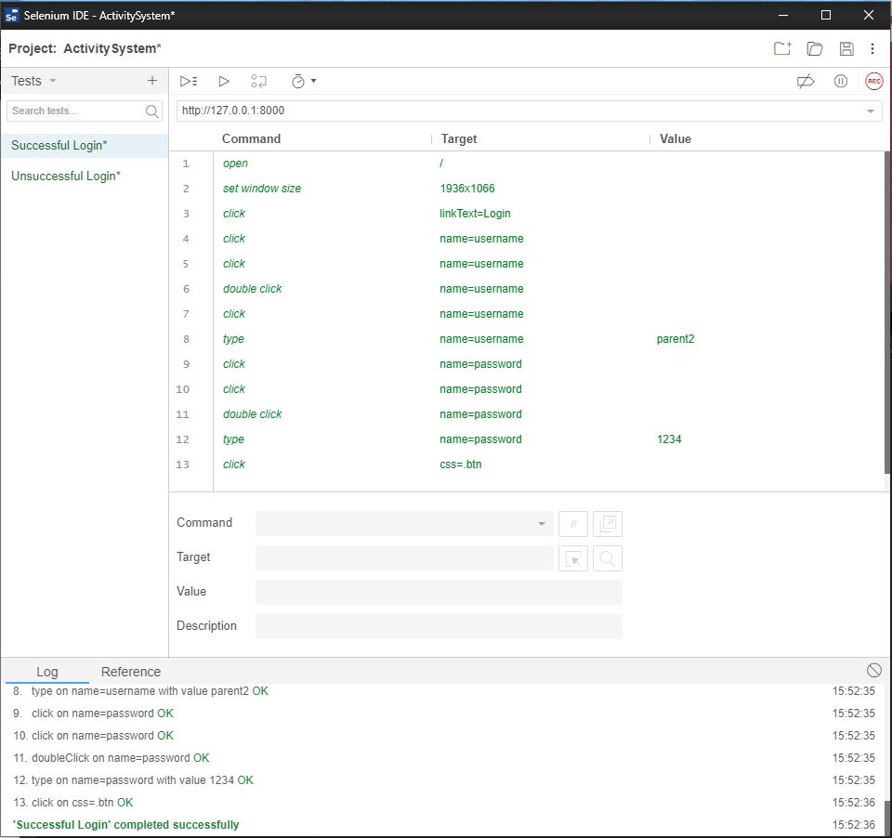

**Test Case**

|  |  |  |  |  |
| --- | --- | --- | --- | --- |
| Test case ID | Requirements | Input test data | Expected outcomes | Actual outcomes |
| TC06 | Check if elements are on the login page | <http://127.0.0.1:8000/login/> | “username” field is present  “password” field is present | As expected |
| TC07 | User is authenticated correctly | username = “parent2”  password = “1234”  Click “Login” | Successfully logged into system | As expected |
| TC08 | Username and password are blank | username = “”  password = “”  Click “Login” | Error Message: “Please check your username and password.” | As expected |
| TC09 | Username is blank | username = “”  password = “1234”  Click “Login” | Error Message: “Please check your username and password.” | As expected |
| TC010 | password is blank | username = “parent40”  password = “”  Click “Login” | Error Message: “Please check your username and password.” | As expected |

**Successful Registration**

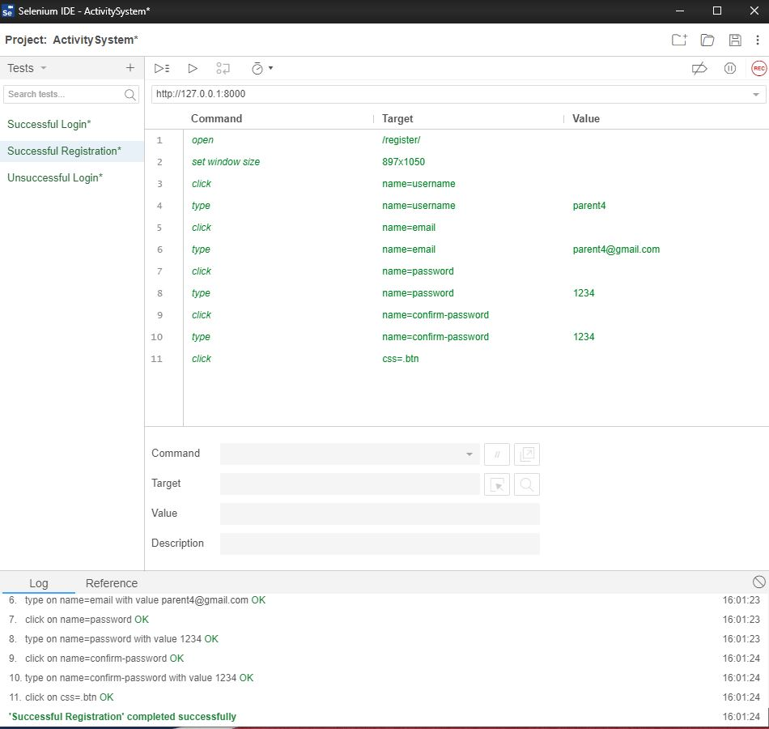

**Test Case**

|  |  |  |  |  |
| --- | --- | --- | --- | --- |
| Test case ID | Requirements | Input test data | Expected outcomes | Actual outcomes |
| TC011 | Check if elements are on the register page | <http://127.0.0.1:8000/register/> | “username” field is present  “password” field is present  “Email” field is present  “Parent” radio button is present  “Teacher” radio button  “Confirm Password” is present | As expected |
| TC012 | User is authenticated correctly | username = “parent4”  password = “1234”  email = [parent4@gmail.com](mailto:parent4@gmail.com)  user = parent  Confirm Password = “1234”  Click “Login” | Successfully logged into system | As expected |
| TC013 | Username and password are blank | username = “”  password = “”  Click “Login” | Error Message: “The given username must be set.” | As expected |
| TC014 | Username is blank | username = “”  password = “1234”  Click “Login” | Error Message: “The given username must be set.” | As expected |
| TC015 | password is blank | username = “parent40”  password = “”  Click “Login” | Error Message: “The given username must be set.” | As expected |
| TC016 | Email is blank | username = “parent40”  password = “1234”  email = “”  Click “Login” | Error Message: “Please include an ‘@’ in your email.” | As expected |

**Enroll Functionality test**

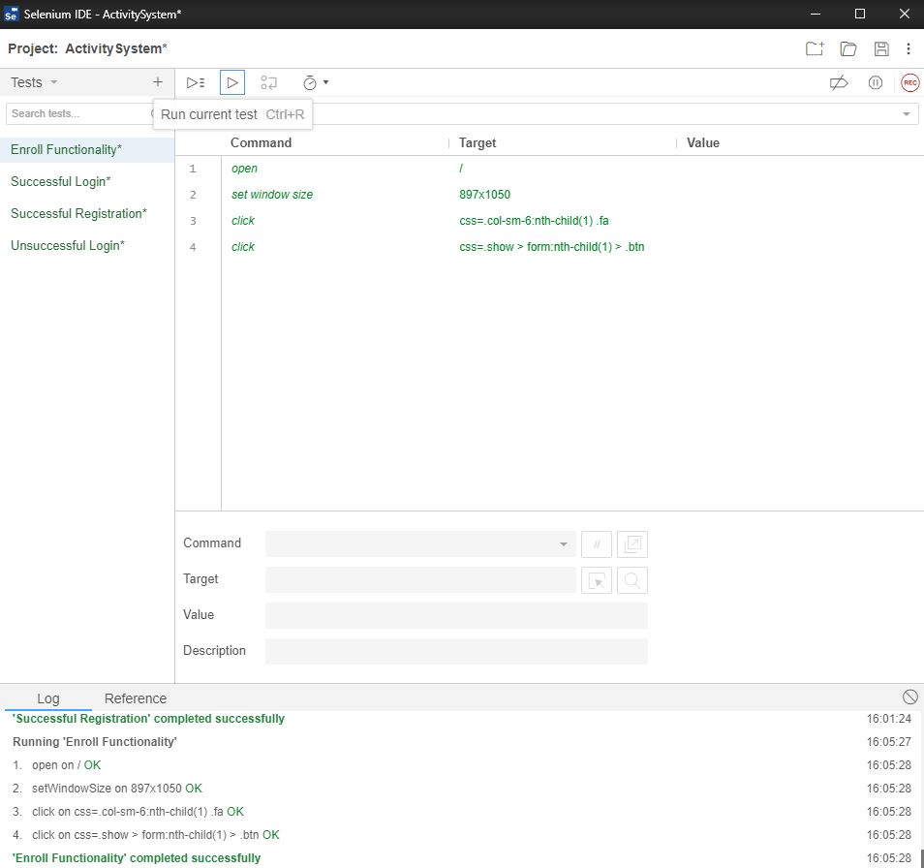

**Test Case**

|  |  |  |  |  |
| --- | --- | --- | --- | --- |
| Test case ID | Requirements | Input test data | Expected outcomes | Actual outcomes |
| TC011 | Check if enroll child button works | <http://127.0.0.1:8000/> | Upon clicking on child it should redirect to “child-profile.html” | As expected |

**Update Functionality Test**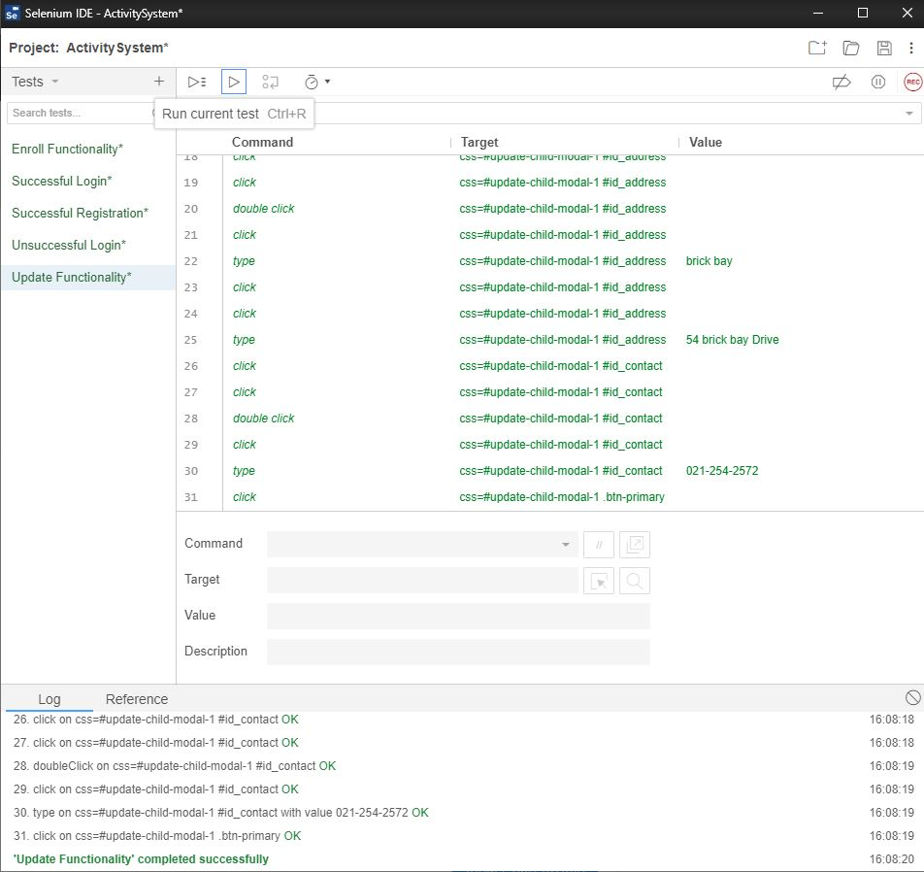

**Test Case**

|  |  |  |  |  |
| --- | --- | --- | --- | --- |
| Test case ID | Requirements | Input test data | Expected outcomes | Actual outcomes |
| TC011 | Check if update child button works | <http://127.0.0.1:8000/>myprofile | Upon clicking on child it should redirect to show modal with original details and change them when clicking ‘update child’ | As expected |

**Delete Functionality Test**

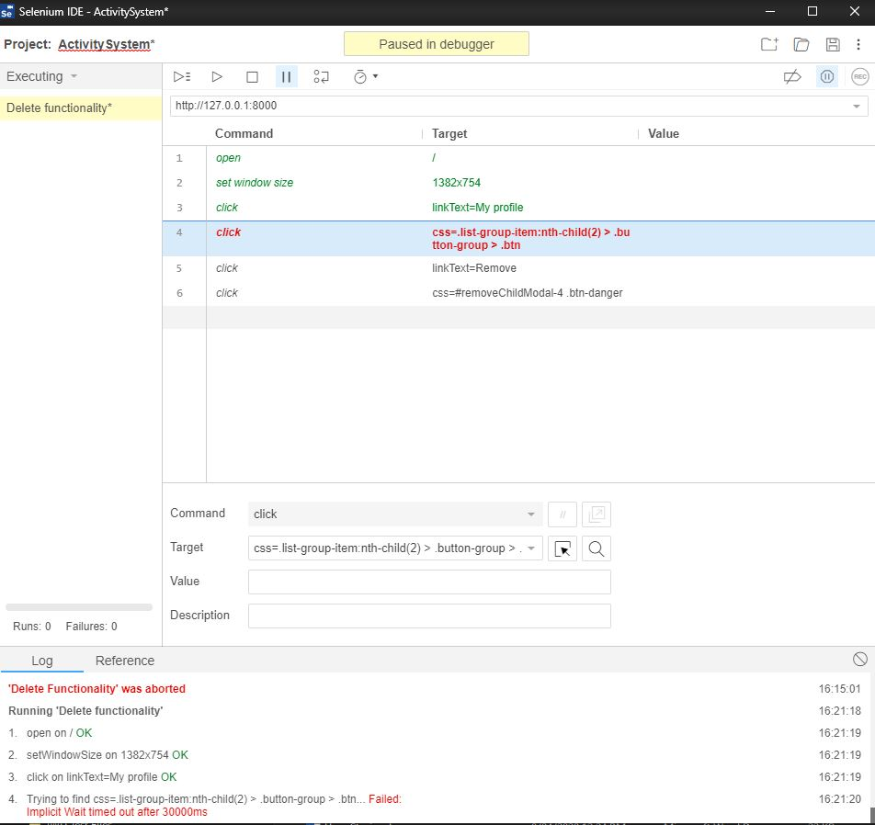

**Test Case**

|  |  |  |  |  |
| --- | --- | --- | --- | --- |
| Test case ID | Requirements | Input test data | Expected outcomes | Actual outcomes |
| TC011 | Check if delete child button works | <http://127.0.0.1:8000/>myprofile | Upon clicking on delete child it should remove child from parent profile page | It works as expected in the browser however selenium had troubles running it. |

**WIP Kanbanize board**

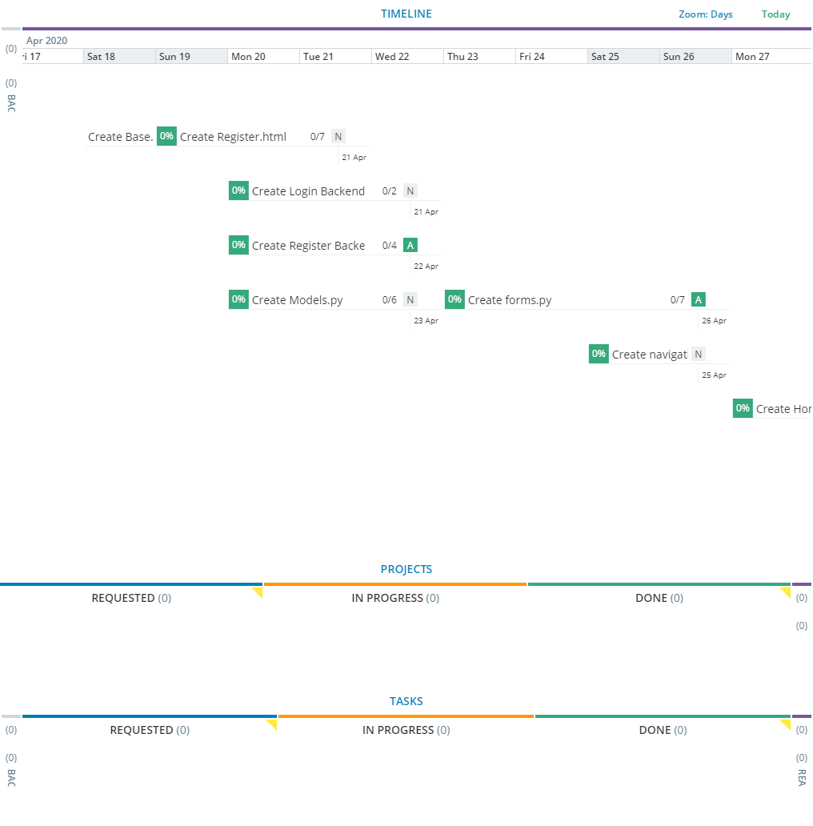

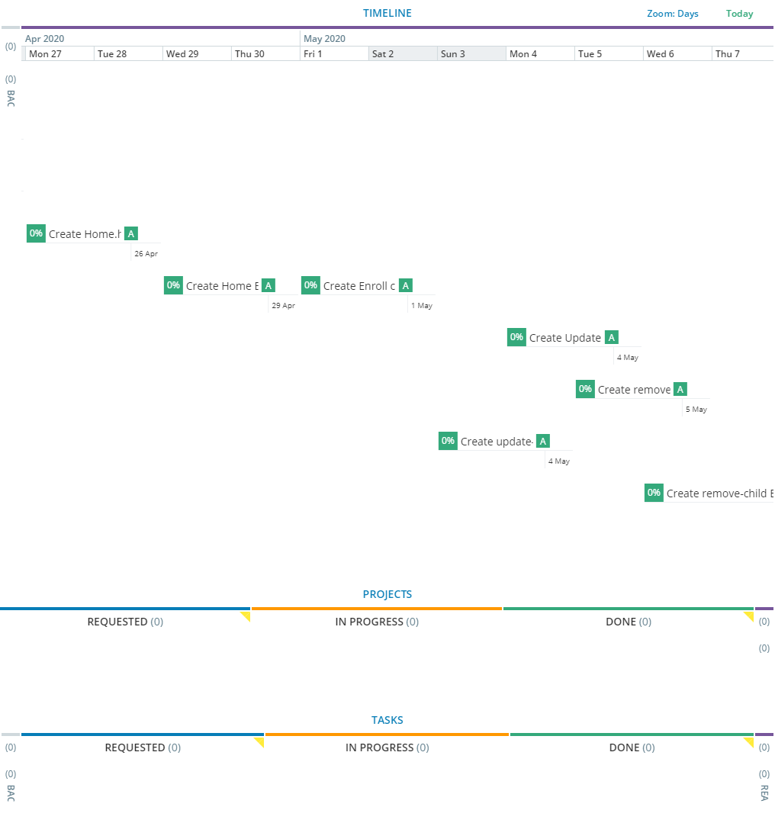

**Milestone 5**

# User Stories

## Sprint 1 (Done)

**High Priority Parent User Stories**

1. **PRIORITY: HIGH *- As a*** *Parent* ***I want to*** Login my children(s) activities onlineaccount ***so that*** I can access and manage my account.

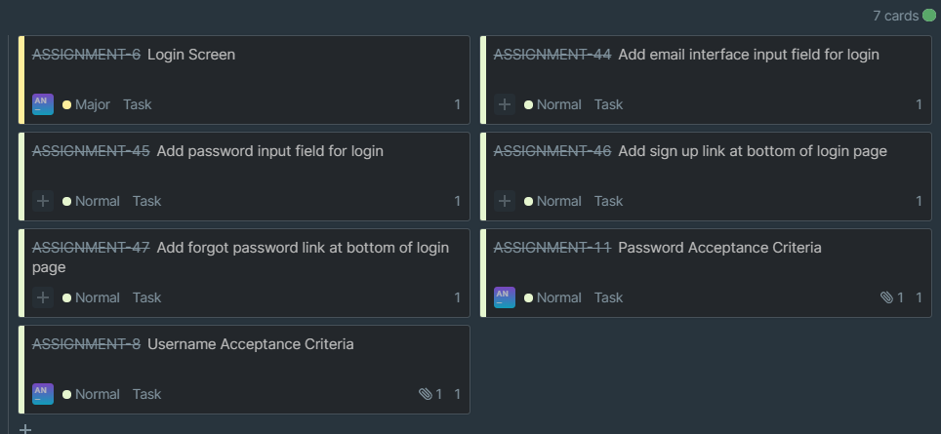

**Story Point Estimation: 2**

1. **PRIORITY: HIGH *- As a*** *Parent* ***I want to*** register a children(s) activities onlineaccount ***so that*** I can enroll my children(s) activities online.

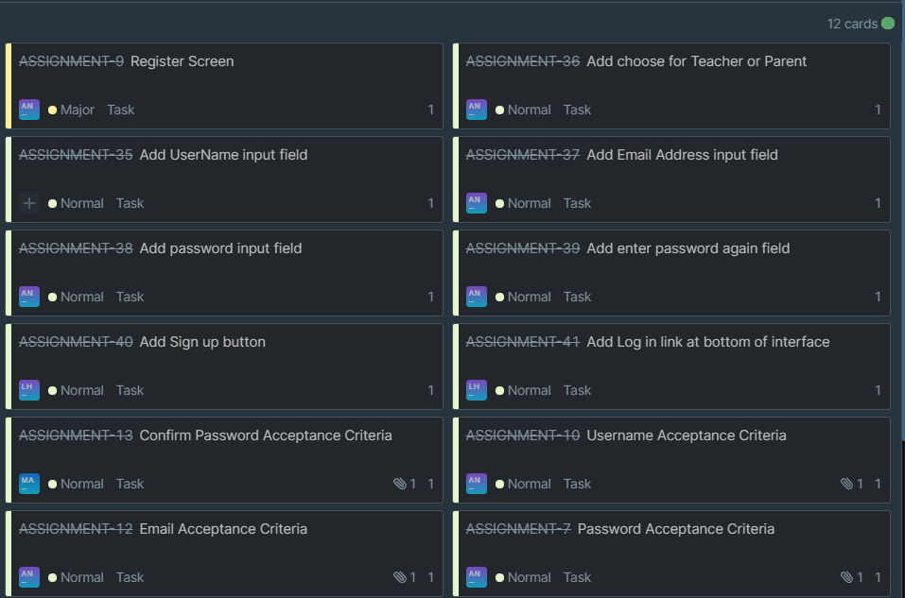

**Story Point estimation: 3**

1. **PRIORITY: HIGH*****- As a*** *Parent* ***I want to*** enroll my children(s) activities online ***so that*** I don’t have to manually input into the paper-based calendar, reducing error and effort in the process***.***

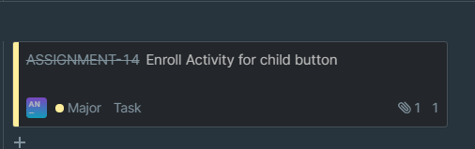

**Story Point estimation: 8**

1. **PRIORITY: HIGH –** As a *Parent* **I want to** view the list of children at home page **so that** I can manage my children easily.

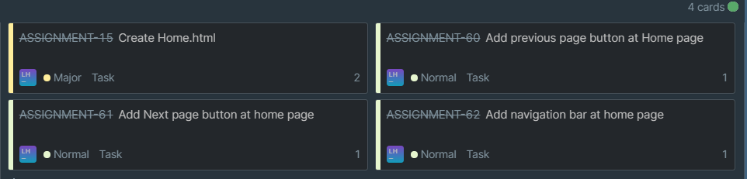

**Story Point estimation: 5**

1. **PRIORITY: HIGH *- As a*** *Parent* ***I want to*** update my children(s) time slot of an activity online ***so that*** I don’t have to manually change the paper-based calendar, reducing error and effort in the process***.***

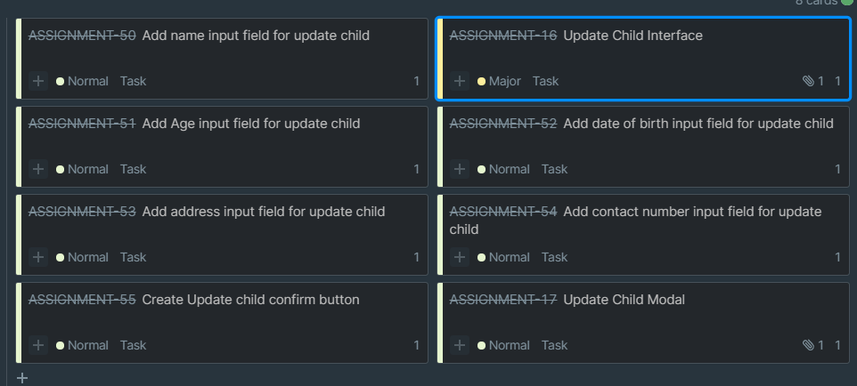

**Story Point estimation: 5**

1. **PRIORITY: HIGH *- As a*** *Parent* ***I want to*** remove my children(s) enrolled activities online ***so that*** I don’t have to manually delete from the paper-based calendar, reducing error and effort in the process***.***

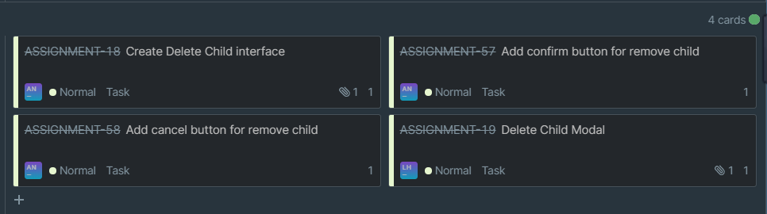

**Story Point estimation: 5**

1. **PRIORITY: HIGH *- As a*** *Parent* ***I want to*** add a child online ***so that*** I don’t have to manually input their details into the paper-based calendar, reducing error and effort in the process***.***

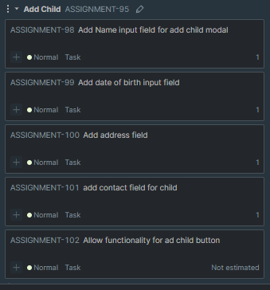

**Story Point Estimation: 5**

## Sprint 2(Done)

**High Priority Teacher User Stories**

1. **PRIORITY: HIGH *- As a*** *Teacher* ***I want to*** add activities to the calendar ***so that*** I don’t have to manually input into the paper-based calendar, reducing error and effort in the process***.***

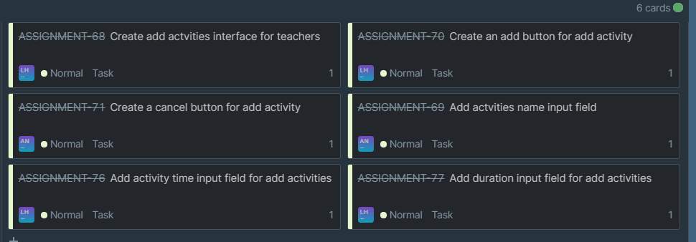

**Story Point Estimation: 5**

1. **PRIORITY: HIGH –** As a *Teacher* **I want to** view the list of activities at

teacher’s home page **so that** I can manage activities easily.

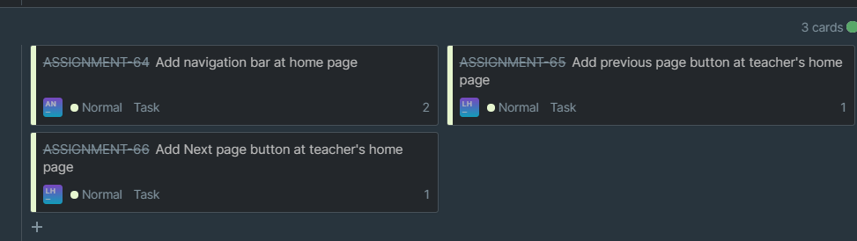

**Story Point Estimation: 3**

1. **PRIORITY: HIGH *- As a*** *Teacher* ***I want to*** delete/remove activities from calendar ***so that*** I don’t have to manually delete from the paper-based calendar, reducing error and effort in the process***.***

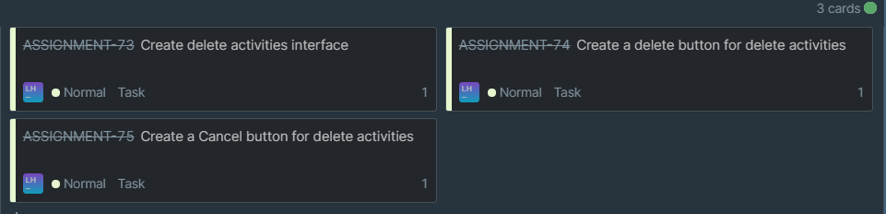

**Story Point Estimation: 3**

1. **PRIORITY: HIGH *- As a*** *Teacher* ***I want to*** update activities from calendar ***so that*** I don’t have to manually change the paper-based calendar, reducing error and effort in the process***.***

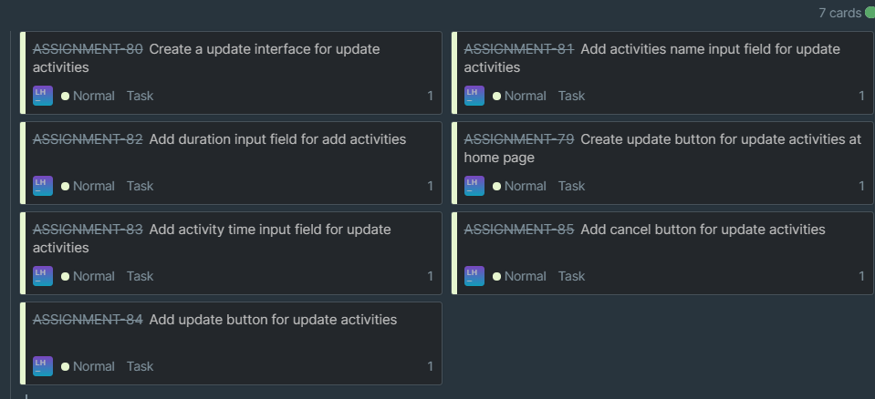

**Story Point Estimation: 5**

1. **PRIORITY: HIGH** - ***As a*** *Teacher* ***I want to*** view children activities on a calendar so that I can see clearly when they are starting and finishing

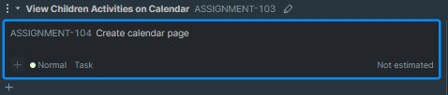

**Story Point Estimation: 8**

## Sprint 3

**Medium Priority Parent User Stories**

1. **PRIORITY: MEDIUM** - ***As a*** *Parent* ***I want to*** view my children(s) lists of enrolled activities online ***so that*** I can view how many activities and what activities they are enrolled in.

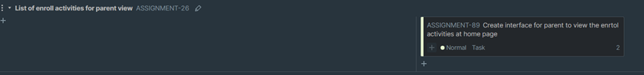

1. **PRIORITY: MEDIUM** - ***As a*** *Teacher* ***I want to*** view a list of children enrolled in my activity ***so that*** I can view what children should be at my activity when I am leading the session.

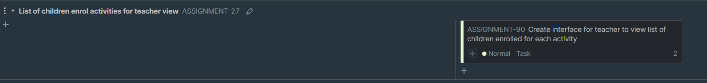

1. **PRIORITY: MEDIUM** **- *As a*** *Parent* ***I want to*** view thedriving time approximation ***so that*** I can plan my journey and be less prone to being late to the activity***.***

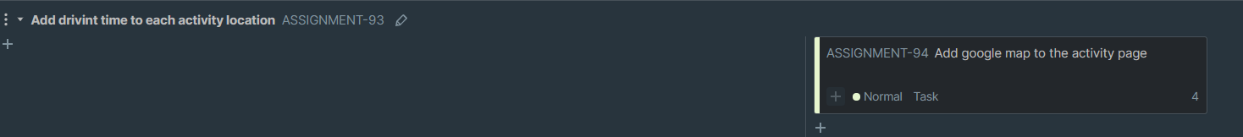

**Low Priority Parent User Stories**

1. **PRIORITY: LOW** - ***As a*** *Parent* ***I want to*** view the teacher who is leading the activity ***so that*** I can decide if my child wants to be in an activity with a specific teacher.

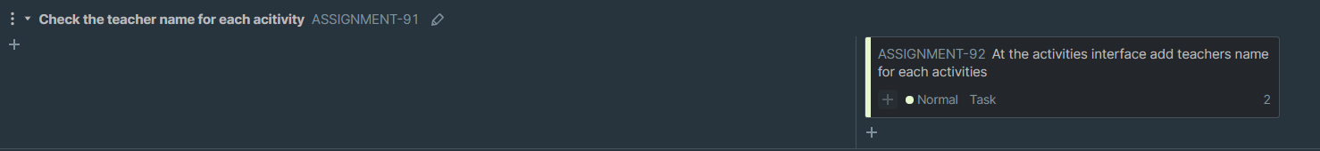

# Burndown Chart

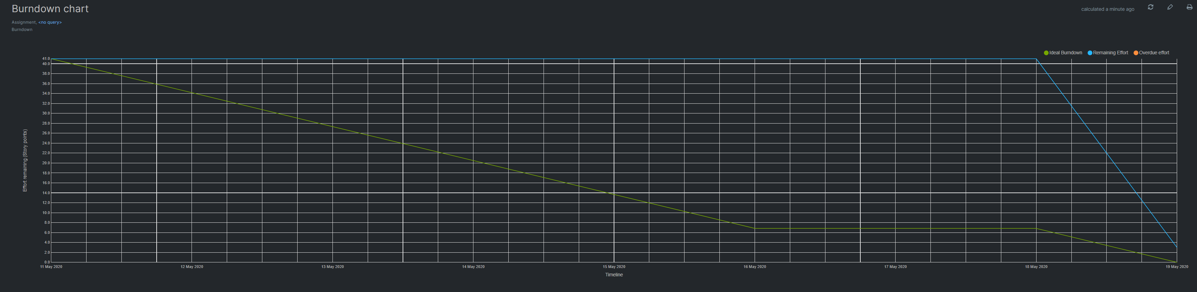

# INVEST Acceptance Criteria (Create Register Screen)

|  |  |
| --- | --- |
| I - Independent | Yes – this story can be developed independently of other user stories |
| N – Negotiable | Register screen should be negotiated within team members as to what it should look like, and what restrictions should be put in place in terms of account privacy. |
| V - Valuable | Having the ability to Register into a system means the teacher or parent can have access into the system by logging in as either a parent or a teacher. |
| E - Estimable | This story would require about 2 to 3 hours to complete. |
| S – Small or Sized Appropriately | The story is small enough to be dealt with by a team member without too much difficulty |
| T - Testable | The story will be tested by checking to see if the user is logged in as their account name by showing a successful message. Or if it is not the right username or password, the system should send an error message. |

**Create Login Screen**

|  |  |
| --- | --- |
| I – Independent | Yes – this story can be developed independently of other user stories |
| N – Negotiable | Login screen should be negotiated within team members as to what it should look like, and what restrictions should be put in place in terms of account privacy. |
| V - Valuable | Having the ability to log into a system means the teacher or parent can perform scheduling, updating and deleting tasks from an application rather than have to do it manually |
| E - Estimable | This story would require about 2 to 3 hours to complete. |
| S – Small or Sized Appropriately | The story is small enough to be dealt with by a team member without too much difficulty |
| T - Testable | The story will be tested by checking to see if the user is logged in as their account name by showing a successful message. Or if it is not the right username or password, the system should send an error message. |

|  |  |
| --- | --- |
| I-Independent | Yes – this story can be developed independently of other user stories |
| N – Negotiable | Enroll functionality should be negotiated within team members as to what it should do, and what happens when a parent clicks on enroll child activity. |
| V - Valuable | Having the ability to enroll a child’s activity means the parent can perform scheduling, updating and deleting tasks from an application rather than have to do it manually |
| E - Estimable | This story would require about 3 to 4 hours to complete. |
| S – Small or Sized Appropriately |  |
| T - Testable | The story will be tested by checking to see if the parent is able to enroll a child’s activity successfully. It should be seen in the ‘My Profile’ page and also shown in the back end by looking at the admin page in Django. |

**Enroll a child**

**Update a Child**

|  |  |
| --- | --- |
| I-Independent | Yes – this story can be developed independently of other user stories |
| N – Negotiable | Update functionality should be negotiated within team members as to what it should do, and what happens when a parent clicks on Update Child Details. |
| V - Valuable | Having the ability to Update a child’s details means the parent can perform scheduling, updating and deleting tasks from an application rather than have to do it manually |
| E - Estimable | This story would require about 3 to 4 hours to complete. |
| S – Small or Sized Appropriately | The story will be medium sized. It should be similar to add child activity. There might be some impediments encountered but they should be solved easily. |
| T - Testable | The story will be tested by checking to see if the parent is able to update a child successfully. It should be seen in the ‘My Profile’ page and also shown in the back end by looking at the admin page in Django when updated successfully. |

|  |  |
| --- | --- |
| I-Independent | Yes – this story can be developed independently of other user stories |
| N – Negotiable | Delete functionality should be negotiated within team members as to what it should do, and what happens when a parent clicks on Delete Child. |
| V - Valuable | Having the ability to Delete a child means the parent can perform scheduling, updating and deleting tasks from an application rather than have to do it manually |
| E - Estimable | This story would require about 3 to 4 hours to complete. |
| S – Small or Sized Appropriately | The story will be medium sized. One or two other group members should try and fix a problem if there is one. |
| T - Testable | The story will be tested by checking to see if the parent is able to delete a child successfully. It should be seen in the ‘My Profile’ page and also shown to be deleted in the back end by looking at the admin page in Django. |

**Delete a Child**

**Add a Child**

|  |  |
| --- | --- |
| I-Independent | Yes – this story can be developed independently of other user stories |
| N – Negotiable | Add functionality should be negotiated within team members as to what it should do, and what happens when a parent clicks on Add Child. |
| V - Valuable | Having the ability to Add a child means the parent can perform scheduling, updating and deleting tasks from an application rather than have to do it manually |
| E - Estimable | This story would require about 3 to 4 hours to complete. |
| S – Small or Sized Appropriately | The story will be medium sized. One or two other group members should try and fix a problem if there is one. |
| T - Testable | The story will be tested by checking to see if the parent is able to Add a child successfully. It should be seen in the ‘My Profile’ page . |

# Acceptance Criteria for sprint 1

**Add an Activity**

|  |  |
| --- | --- |
| I-Independent | Yes – this story can be developed independently of other user stories |
| N – Negotiable | Add functionality should be negotiated within team members as to what it should do, and what happens when a teacher clicks on Add Activity. |
| V - Valuable | Having the ability to Add an activity means the teacher can perform scheduling, updating and deleting tasks from an application rather than have to do it manually |
| E - Estimable | This story would require about 3 to 4 hours to complete. |
| S – Small or Sized Appropriately | The story will be medium sized. One or two other group members should try and fix a problem if there is one. |
| T - Testable | The story will be tested by checking to see if the teacher is able to Add an activity successfully. It should be seen in the ‘My Profile’ page . |

**Update an Activity**

|  |  |
| --- | --- |
| I-Independent | Yes – this story can be developed independently of other user stories |
| N – Negotiable | Update functionality should be negotiated within team members as to what it should do, and what happens when a teacher clicks on Add Activity. |
| V - Valuable | Having the ability to update an activity means the teacher can perform scheduling, updating and deleting tasks from an application rather than have to do it manually |
| E - Estimable | This story would require about 3 to 4 hours to complete. |
| S – Small or Sized Appropriately | The story will be medium sized. One or two other group members should try and fix a problem if there is one. |
| T - Testable | The story will be tested by checking to see if the teacher is able to Update an activity successfully. It should be seen in the ‘My Profile’ page . |

**Delete an Activity**

|  |  |
| --- | --- |
| I-Independent | Yes – this story can be developed independently of other user stories |
| N – Negotiable | Delete functionality should be negotiated within team members as to what it should do, and what happens when a teacher clicks on Add Activity. |
| V - Valuable | Having the ability to Delete an activity means the teacher can perform scheduling, updating and deleting tasks from an application rather than have to do it manually |
| E - Estimable | This story would require about 3 to 4 hours to complete. |
| S – Small or Sized Appropriately | The story will be medium sized. One or two other group members should try and fix a problem if there is one. |
| T - Testable | The story will be tested by checking to see if the teacher is able to Delete an activity successfully. It should be seen in the ‘My Profile’ page . |

**View Activity in Calendar**

|  |  |
| --- | --- |
| I-Independent | Yes – this story can be developed independently of other user stories |
| N – Negotiable | View activities in calendar functionality should be negotiated within team members as to what it should do, and what happens when a teacher clicks on Calendar. |
| V - Valuable | Having the ability to View activities in calendar means the teacher can view and manage their activities far more clearly. |
| E - Estimable | This story would require about 3 to 4 hours to complete. |
| S – Small or Sized Appropriately | The story will be medium sized. One or two other group members should try and fix a problem if there is one. |
| T - Testable | The story will be tested by checking to see if the teacher is able to view activities on calendar successfully. It should be seen in the ‘My Profile’ page . |

# Selenium Automated Tests

**Invalid Login**



**Test Case**

|  |  |  |  |  |
| --- | --- | --- | --- | --- |
| Test case ID | Requirements | Input test data | Expected outcomes | Actual outcomes |
| TC01 | Check if elements are on the login page | <http://127.0.0.1:8000/login/> | “username” field is present  “password” field is present | As expected |
| TC02 | User is authenticated correctly | username = “parent40”  password = “1234”  Click “Login” | Error Message: “Please check your username and password.” | As expected |
| TC03 | Username and password are blank | username = “”  password = “”  Click “Login” | Error Message: “Please check your username and password.” | As expected |
| TC04 | Username is blank | username = “”  password = “1234”  Click “Login” | Error Message: “Please check your username and password.” | As expected |
| TC05 | password is blank | username = “parent40”  password = “”  Click “Login” | Error Message: “Please check your username and password.” | As expected |

**Successful Login**



**Test Case**

|  |  |  |  |  |
| --- | --- | --- | --- | --- |
| Test case ID | Requirements | Input test data | Expected outcomes | Actual outcomes |
| TC06 | Check if elements are on the login page | <http://127.0.0.1:8000/login/> | “username” field is present  “password” field is present | As expected |
| TC07 | User is authenticated correctly | username = “parent2”  password = “1234”  Click “Login” | Successfully logged into system | As expected |
| TC08 | Username and password are blank | username = “”  password = “”  Click “Login” | Error Message: “Please check your username and password.” | As expected |
| TC09 | Username is blank | username = “”  password = “1234”  Click “Login” | Error Message: “Please check your username and password.” | As expected |
| TC010 | password is blank | username = “parent40”  password = “”  Click “Login” | Error Message: “Please check your username and password.” | As expected |

**Successful Registration**



**Test Case**

|  |  |  |  |  |
| --- | --- | --- | --- | --- |
| Test case ID | Requirements | Input test data | Expected outcomes | Actual outcomes |
| TC011 | Check if elements are on the register page | <http://127.0.0.1:8000/register/> | “username” field is present  “password” field is present  “Email” field is present  “Parent” radio button is present  “Teacher” radio button  “Confirm Password” is present | As expected |
| TC012 | User is authenticated correctly | username = “parent4”  password = “1234”  email = [parent4@gmail.com](mailto:parent4@gmail.com)  user = parent  Confirm Password = “1234”  Click “Login” | Successfully logged into system | As expected |
| TC013 | Username and password are blank | username = “”  password = “”  Click “Login” | Error Message: “The given username must be set.” | As expected |
| TC014 | Username is blank | username = “”  password = “1234”  Click “Login” | Error Message: “The given username must be set.” | As expected |
| TC015 | password is blank | username = “parent40”  password = “”  Click “Login” | Error Message: “The given username must be set.” | As expected |
| TC016 | Email is blank | username = “parent40”  password = “1234”  email = “”  Click “Login” | Error Message: “Please include an ‘@’ in your email.” | As expected |

**Enroll Functionality test**



**Test Case**

|  |  |  |  |  |
| --- | --- | --- | --- | --- |
| Test case ID | Requirements | Input test data | Expected outcomes | Actual outcomes |
| TC011 | Check if enroll child button works | <http://127.0.0.1:8000/> | Upon clicking on child it should redirect to “child-profile.html” | As expected |

**Update Functionality Test**

**Test Case**

|  |  |  |  |  |
| --- | --- | --- | --- | --- |
| Test case ID | Requirements | Input test data | Expected outcomes | Actual outcomes |
| TC012 | Check if update child button works | <http://127.0.0.1:8000/>myprofile | Upon clicking on child it should redirect to show modal with original details and change them when clicking ‘update child’ | As expected |
| TC013 | Name is blank | username = “”  Click “Update Child” | Error Message: “Please fill out this field.” | As expected |
| TC014 | Date of Birth is blank | Dd/mm/yyyy = “”  Click “Update Child” | Error Message: “Please fill out this field.” | As expected |
| TC015 | **Age is blank** | **Age = “”**  **Click “Update Child”** | **Error Message: “Please fill out this field.”** | **As expected** |
| TC016 | Address is blank | Address = “”  Click “Update Child” | Error Message: “Please fill out this field.” | As expected |
| TC017 | Contact is blank | Contact = “”  Click “Update Child” | Error Message: “Please fill out this field.” | As expected |

**Delete Functionality Test**



**Test Case**

|  |  |  |  |  |
| --- | --- | --- | --- | --- |
| Test case ID | Requirements | Input test data | Expected outcomes | Actual outcomes |
| TC018 | Check if delete child button works | <http://127.0.0.1:8000/>myprofile | Upon clicking on delete child it should remove child from parent profile page | It works as expected in the browser however selenium had troubles running it. |

**Add Child Functionality**

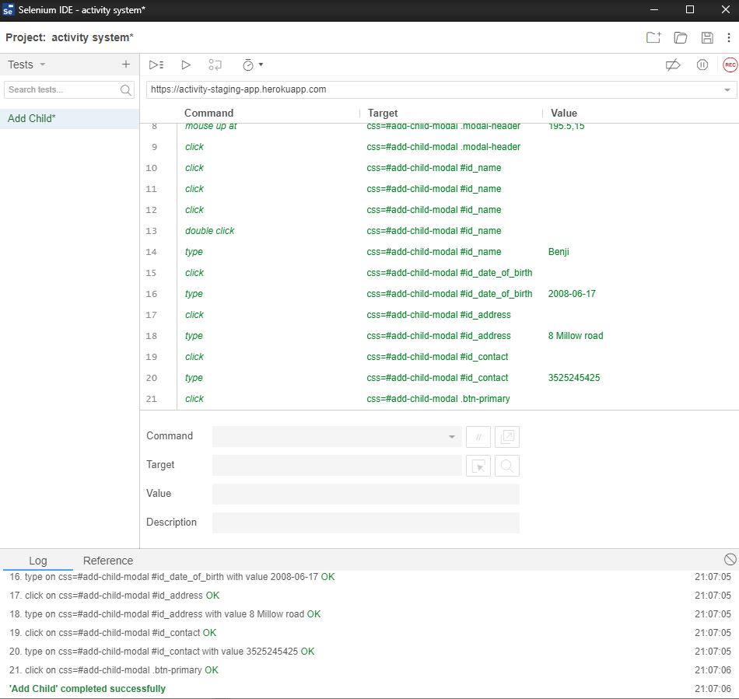

**Test Case**

|  |  |  |  |  |
| --- | --- | --- | --- | --- |
| Test case ID | Requirements | Input test data | Expected outcomes | Actual outcomes |
| TC019 | Check if Add child button works | <http://127.0.0.1:8000/>myprofile | Upon clicking on add child it should add a child to the parent profile page. | As expected |
| TC020 | Name is blank | username = “”  Click “Add Child” | Error Message: “Please fill out this field.” | As expected |
| TC021 | Date of Birth is blank | Dd/mm/yyyy = “”  Click “Add Child” | Error Message: “Please fill out this field.” | As expected |
| TC022 | Age is blank | Age = “”  Click “Add Child” | Error Message: “Please fill out this field.” | As expected |
| TC023 | Address is blank | Address = “”  Click “Add Child” | Error Message: “Please fill out this field.” | As expected |
| TC024 | Contact is blank | Contact = “”  Click “Add Child” | Error Message: “Please fill out this field.” | As expected |

**Sprint 2 Tests**

**Add Activity Functionality**

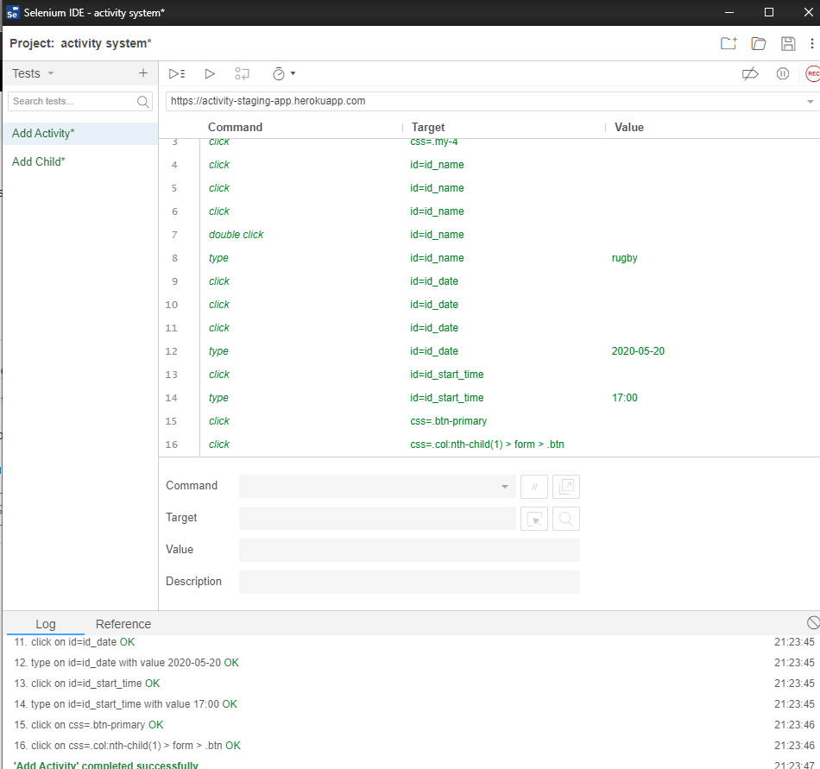

**Test Case**

|  |  |  |  |  |
| --- | --- | --- | --- | --- |
| Test case ID | Requirements | Input test data | Expected outcomes | Actual outcomes |
| TC025 | Check if Add Activity button works | <http://127.0.0.1:8000/>  (Login as Teacher) | Upon clicking on add activity it should add a activity to the teacher profile page. | As expected |
| TC026 | Name is blank | username = “”  Click “Add Activity” | Error Message: “Please fill out this field.” | As expected |
| TC027 | Date of Birth is blank | Dd/mm/yyyy = “”  Click “Add Activity” | Error Message: “Please fill out this field.” | As expected |
| TC028 | Start time | Start Time = “”  Click “Add Activity” | Error Message: “Please fill out this field.” | As expected |
| TC029 | Duration | Contact = “”  Click “Add Activity” | Error Message: “Please fill out this field.” | As expected |

**Update Activity Functionality**



**Test Case**

|  |  |  |  |  |
| --- | --- | --- | --- | --- |
| Test case ID | Requirements | Input test data | Expected outcomes | Actual outcomes |
| TC030 | Check if update Activity button works | <http://127.0.0.1:8000/>  (Login as Teacher) | Upon clicking on update activity it should update a activity to the teacher profile page. | As expected |
| TC031 | Name is blank | username = “”  Click “Update Activity” | Error Message: “Please fill out this field.” | As expected |
| TC032 | Date of Birth is blank | Dd/mm/yyyy = “”  Click “Update Activity” | Error Message: “Please fill out this field.” | As expected |
| TC033 | Start time | Start Time = “”  Click “Update Activity” | Error Message: “Please fill out this field.” | As expected |
| TC034 | Duration | Contact = “”  Click “Update Activity” | Error Message: “Please fill out this field.” | As expected |

**Delete Functionality**

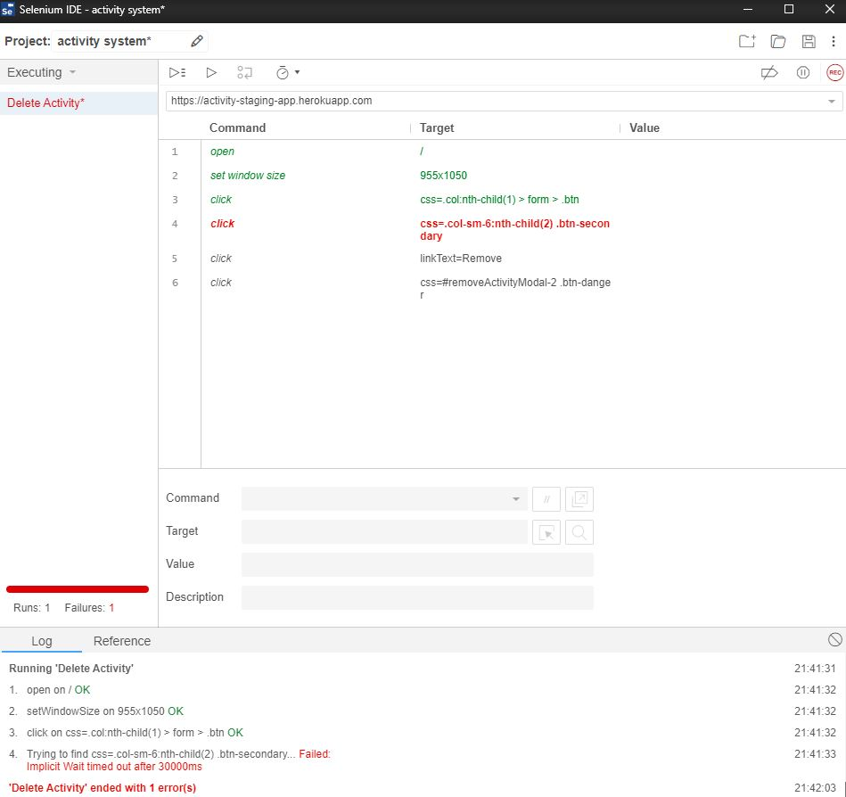

**Test Case**

|  |  |  |  |  |
| --- | --- | --- | --- | --- |
| Test case ID | Requirements | Input test data | Expected outcomes | Actual outcomes |
| TC035 | Check if delete activity button works | <http://127.0.0.1:8000/>  (Login as Teacher) | Upon clicking on delete activity it should remove activity from teacher profile page | It works as expected in the browser however selenium had troubles running it. |

**WIP Kanbanize board**





# Agile and Lean Practices

The agile development model integrates testing into the entire development process and no longer treats it as an independent stage. Simply put, agile testing is continuous feedback and response to software quality issues in a timely manner.

So, we decide to use **Scrum and Test automation**. Scrum is a framework for developing, delivering, and continuously supporting complex products. It is an incremental and iterative development process. In this framework, the entire development process consists of several short iteration cycles. A short iteration cycle is called a Sprint.

In Scrum, the product backlog is used to manage product requirements. The product backlog is a list of requirements sorted by business value. The manifestation of list items is usually a user story. The Scrum team needs to first develop requirements that have a higher value to customers.

In Sprint, the Scrum team selects the highest priority requirements from the product backlog for development. The selected requirements are discussed, analyzed and estimated at the Sprint planning meeting to get the corresponding task list, which we call Sprint backlog. At the end of each iteration, the Scrum team will submit potentially deliverable product increments.

Automated testing is absolutely dominant in agile testing. In the agile development model, it is urgent to require a high degree of automation of the test. An iteration is usually two or three weeks, which means that we only have two or three Days to complete the entire test process of the entire project. Without automation, there is no agile. In the agile testing process, it is mainly divided into the following main testing stages:

Unit Test (UT)

It is to test the correctness of the program module (the smallest unit of software design). The program unit is the smallest testable part of the application. In procedural programming, a unit is a single program, function, process, etc. For object-oriented programming, the smallest unit is a method, including methods in a base class (superclass), abstract class, or derived class (subclass).

Integration Test (IT)

Integration testing is also called assembly testing, that is, the program modules are assembled in a one-time or value-added manner to test the correctness of the interface of the system. Integration testing is generally performed after unit testing and before system testing. Practice has shown that sometimes modules can work alone, but there is no guarantee that they can work simultaneously when assembled.

User Acceptance Test (UAT)

User acceptance test, also known as user acceptance test, is generally in the final stage of the project process. At this time, relevant product managers, business personnel, users or testers test and accept the system according to the test plan and results to decide whether to accept the system. It is a test to determine whether the product can meet the requirements specified by the contract or the user.

Regression Test

Regression testing is a type of software testing designed to check whether the original functions of the software remain intact after modification. Regression testing is mainly for the purpose of checking degradation. Degradation mainly refers to the phenomenon that due to the update of the system version, the function that normally worked in the previous version becomes unable to operate normally, or an issue is urgently fixed, but it causes other problems.

## Stand up Meetings

**Stand up Meetings**

We Plan do 20 meetings (about two meeting a week)

PS：Zoom in to see a clear image.



Milestone 1 Stand up Meetings





Milestone 2 Stand up Meetings













Milestone 3 Stand up Meetings











Milestone 4 Stand up Meetings











Milestone 5 Stand up Meetings (future meeting)





Mileston6 Stand up Meeting (future meeting)



# Velocity

For estimated velocity and actual velocity is just little bit different. In the short term, the velocity is stable and provides a great foundation for improving the accuracy and reliability of the near - and long-term planning of agile projects. Agile delivery cycles are very small, so velocity is quick and can be validated early in the project, and then we rely on it to improve the predictability of the project.

# Estimated Velocity vs Actual Velocity for Sprint 0

For sprint 1 the estimated velocity was **231** however we overestimated some user stories and the actual velocity came down to **168**

# Estimated Velocity vs Actual Velocity for Sprint 1

For sprint 2 the estimated velocity was **231** however we overestimated some user stories and the actual velocity came down to **168**

# Differently in the next sprint

At next sprint we plan let everyone should include both "what we do better" and "what we can improve" in the sprint

For "we can improve" related content, every group member can propose solutions, but if there is no solution, we just simply record the problem

Each person's statement will be recorded, especially the action item will be listed separately

As each person speaks, they can be interrupted by others to initiate a simultaneous discussion on a particular topic

Also use GitHub desktop and make sure to commit each component to the git it an organized, clear and efficient manner.